Visoka škola strukovnih studija

 za informacione i komunikacione

 Tehnologije

ZETA

<https://reddy.epizy.com>

Teodora Nedeljković, 5/18

Smer: Internet Tehnologije

Modul: Web programiranje

Predmet: Praktikum iz Web programiranja PHP

Sadržaj

1  UVOD 4

1.1  Korišćene tehnologije I template 4

1.2  Mapa sajta 4

1.3 Baza podataka –dizajn 5

2 Organizacija 5

2.1 Opis stranica 5

23

2.2 Struktura sajta 24

3 KODOVI 28

3.1 PHP views 28

3.11 index.php 28

3.12 views 29

3.2 PHP models 51

3.21 contact.php 51

3.22 dlExcel.php 52

3.23 dlWord.php 56

3.24 dlWordAuthor.php 57

3.25 fucntions.php 58

3.26 login.php 59

3.27 register.php 60

3.28 artist/functions.php 63

3.29 artist/getAllArtist.php 63

3.210 artist/getOneArtist.php 63

3.211 menu/getAllMenu.php 64

3.212menu/getAllType.php 65

3.213 menu/getOneMenu.php 65

3.214 menuInsert.php 66

3.215 menuUpdate.php 67

3.217 menuDelete.php 68

3.219orders/functions.php 69

3.220 program/filter.php 69

3.221 program/functions.php 70

3.222 program/getOne.php 71

3.223 program/OrderTicket.php 71

3.224 program/programDelete.php 72

3.225 program/programInsert.php 73

3.226 program/programUpdate.php 76

3.227 program/sort.php 78

3.228 stages/functions.php 79

3.229 stages /getAllStage.php 80

3.230 stages /getOneStage.php 80

3.231 stages /stageDelete.php 81

3.232 stages / stageInsert.php 81

3.233 stages / stageUpdate.php 84

3.234 user / functions.php 86

3.235 news/functions.php 86

3.236 news/getAllNews.php 87

3.237 news/getOneNews.php 87

3.238 news/newsDelete.php 87

3.239 news/newsInsert/php 88

3.240 news/newsUpdate.php 89

3.3 PHP config 91

3.31 config/connection.php 91

3.32 config/.env 91

3.33 config/config.php 91

3.4 JS 92

3.5 SCSS 127

# 1  UVOD

## 1.1  Korišćene tehnologije I template

Radjeno je korišćenjem: PHP, JavaScript,Jquery, SASS/CSS, i XML u Sublime text editoru.

Template je ručno pisan.

## 1.2  Mapa sajta

<?xml version="1.0" encoding="UTF-8"?>

<urlset xmlns="http://www.sitemaps.org/schemas/sitemap/0.9" xmlns:xsi="http://www.w3.org/2001/XMLSchema-instance" xsi:schemaLocation="http://www.sitemaps.org/schemas/sitemap/0.9

 http://www.sitemaps.org/schemas/sitemap/0.9/sitemap.xsd">

    <url>

        <loc>https://zetaclub.epizy.com/index.php</loc>

        <lastmod>2020-07-13</lastmod>

        <changefreq>daily</changefreq>

        <priority>1.0</priority>

    </url>

</urlset>

## 1.3 Baza podataka –dizajn

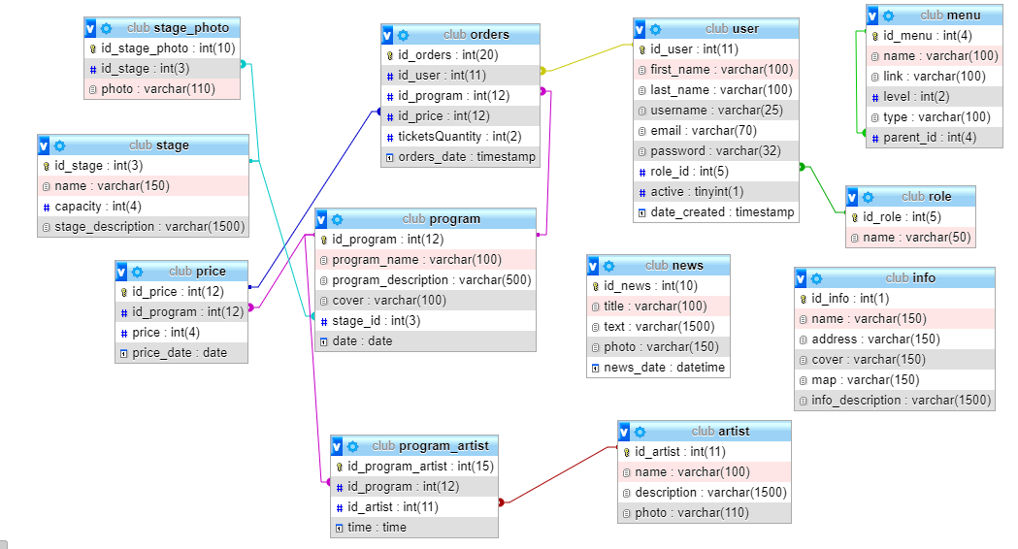

# 2 Organizacija

## 2.1 Opis stranica

MAIN



Dinamicka lista 3 najnovija programa.

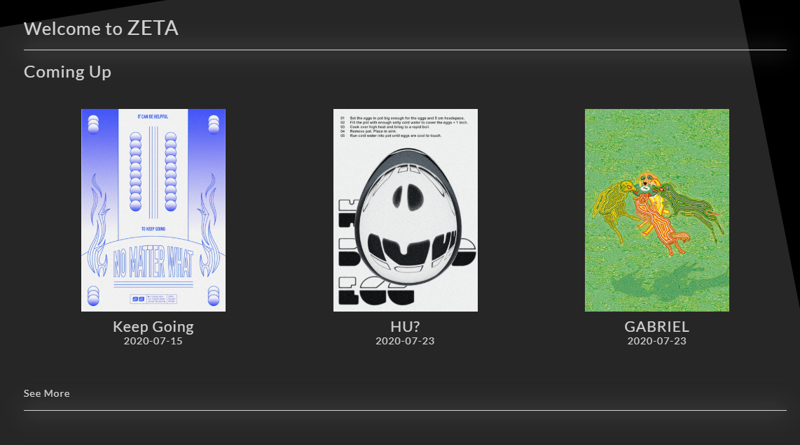

Dinamicki blok sa bazicnim informacijama o klubu

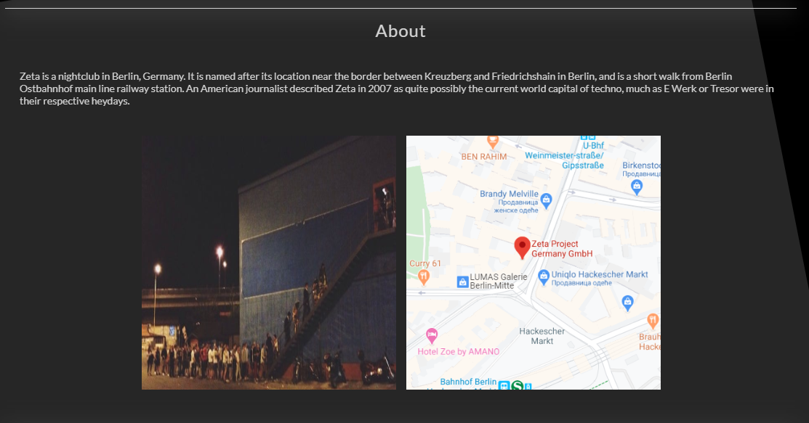

Fiksni dinamicki new blok i blok sa drustvenim mrezama.

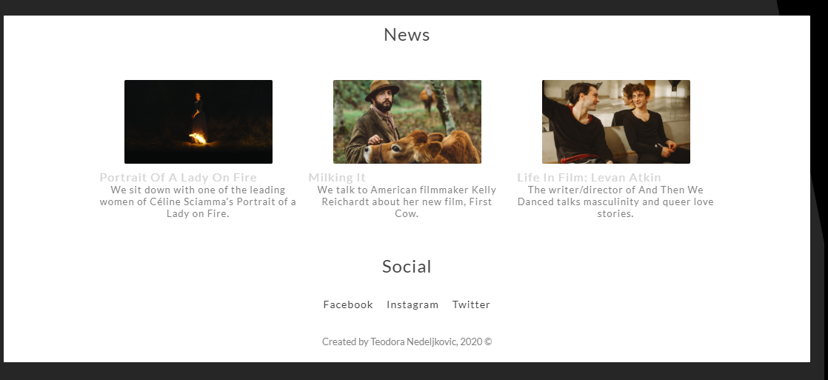

Dinamicki meni

Za neautorizovane korisnike:

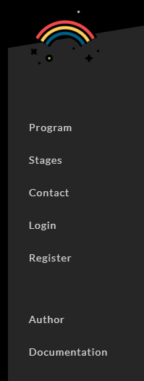

Za autorizovane korisnike: bez logina/registracije, i sa profilom

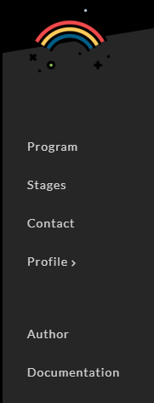

Mogucnost downloada narucenih karata:

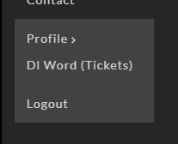

Za admina dodatan link- control panel:

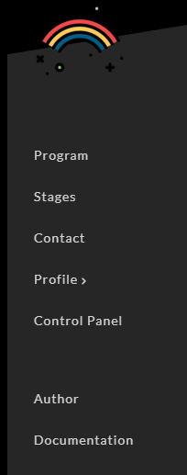

LOGIN

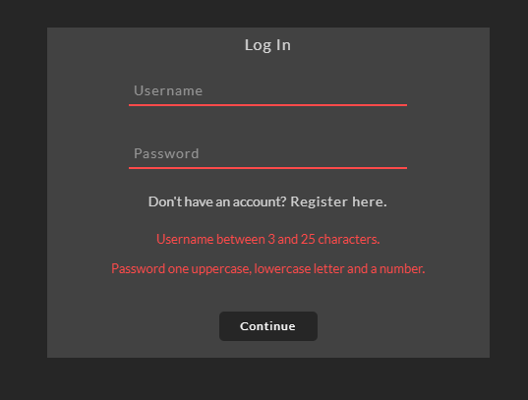

JS provera podataka

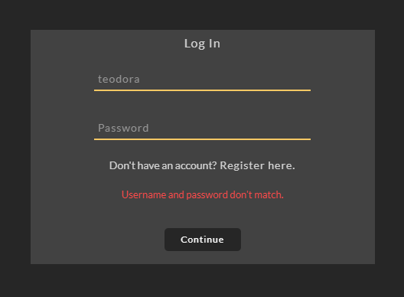

PHP validacija -> opcija da se ne slazu username i password ili da username ne postoji

REGISTRACIJA

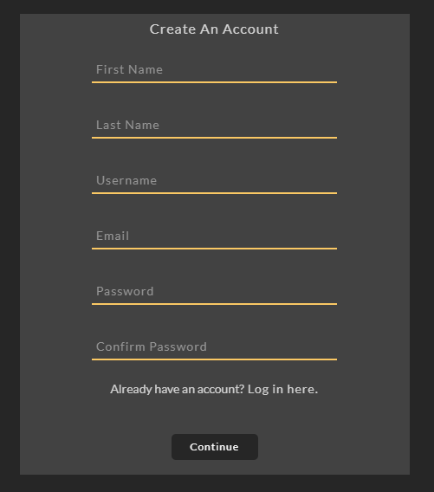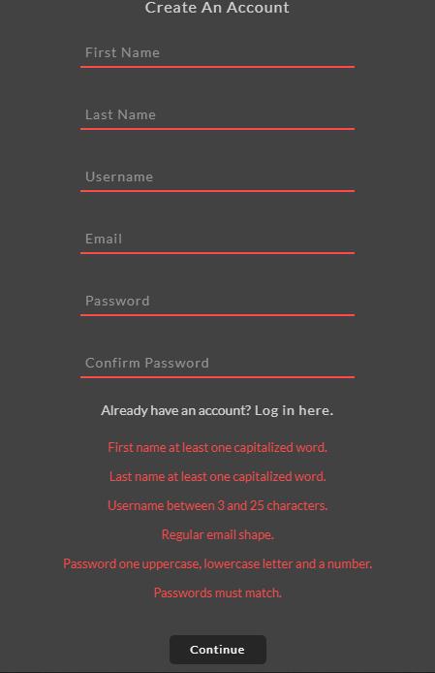

JS validacija i PHP

PROGRAM

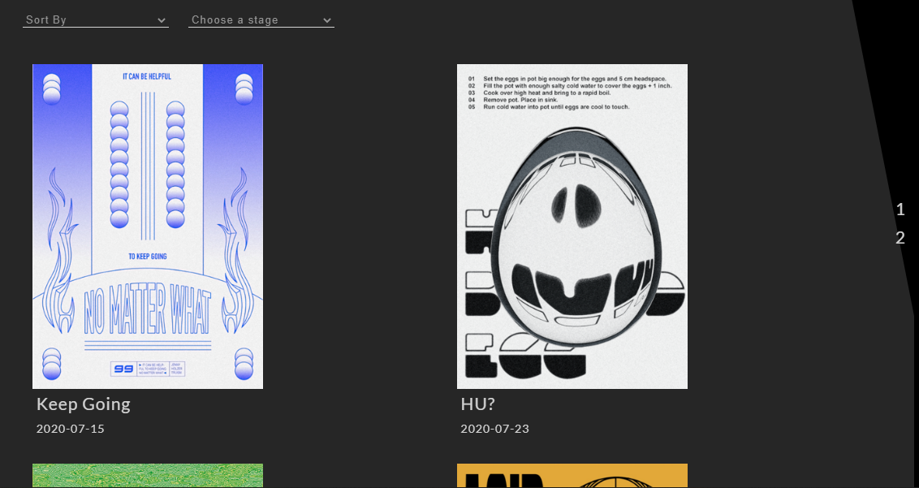

Dinamicki ispisani programi, 6 po strani-slika,ime,datum odrzavanja.

Mogucnost sortiranja i filtriranja po mestu odrzavanja (stage).

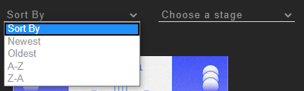

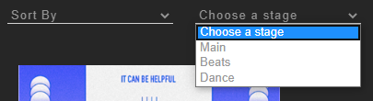

Dinamicka paginacija, izbor strana

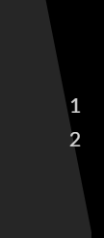

PROGRAM INFO

Klikom na program se otvaraju dodatne informacije

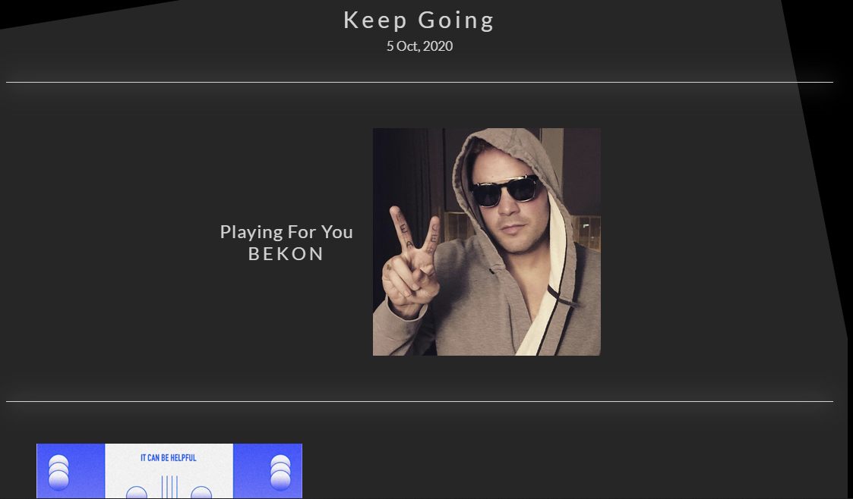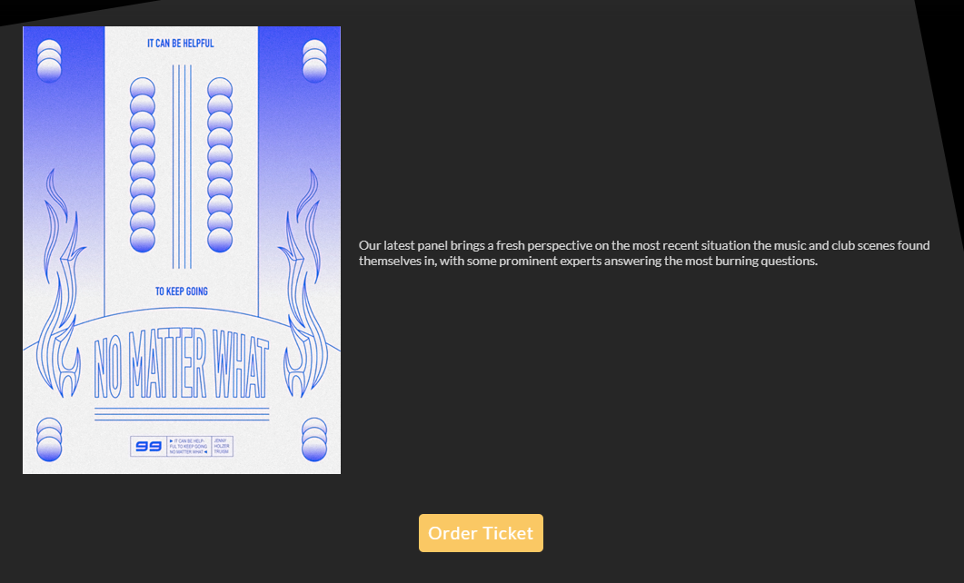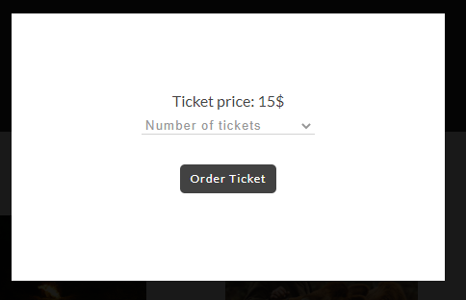

Klikom na order ticket se omogucava narucivanje, samo za autorizovane korisnike. U suprotnom:



STAGES

Izbor stejdzeva,dinamicki ispisani.

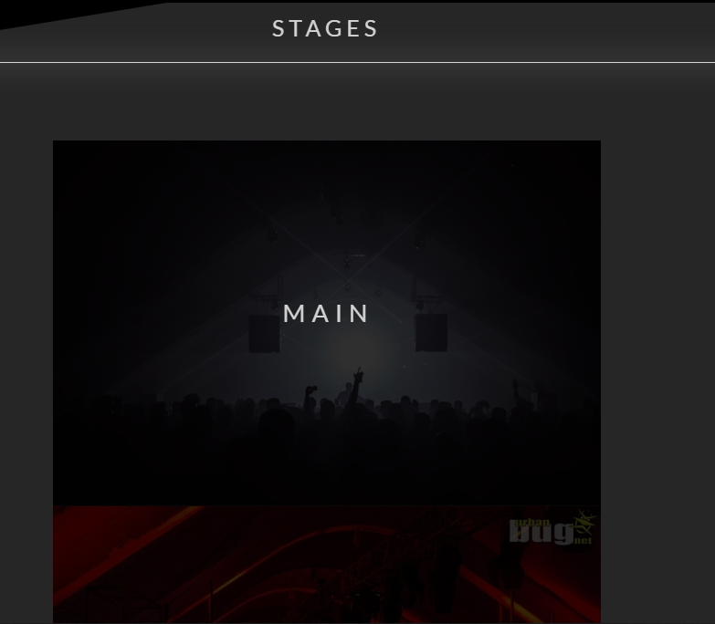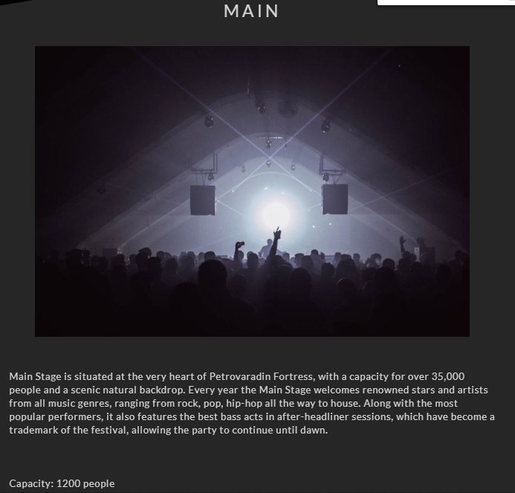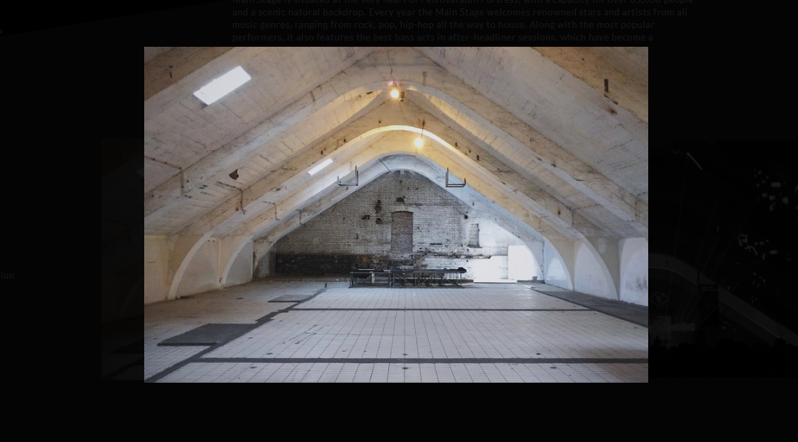

Klik uvelicavanje slike

AUTOR



Klikom na download Word, dobija se word fajl na disku D sa informacijama o autoru.

CONTACT

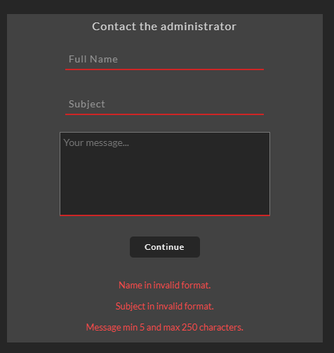

Validacija sa klijentske i serverske strane.

CONTROL PANEL

kontrola menija, programa, stejdzeva i vesti.

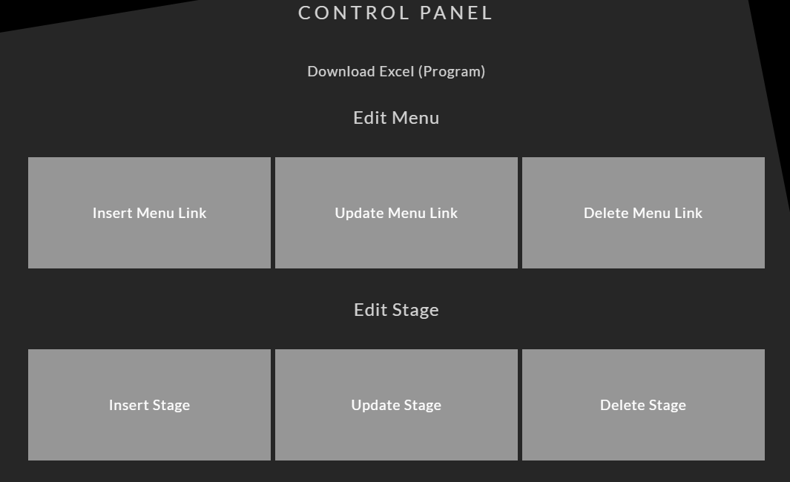

Prilikom inserta stejdza, slika se php-om automatski resize-uje na velicinu koja dogovara dizajnu.



Download excel liste svih buducih programa.

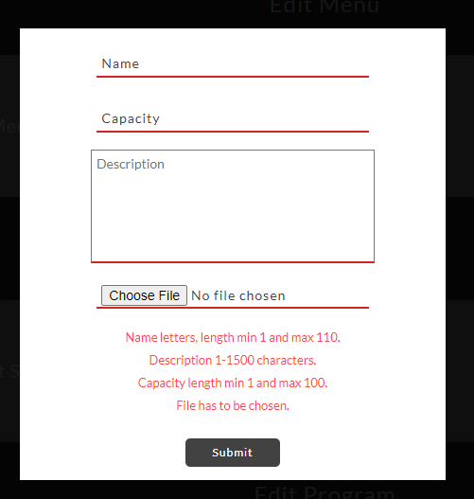

Validacija sa klijentske i serverske strane.

## 

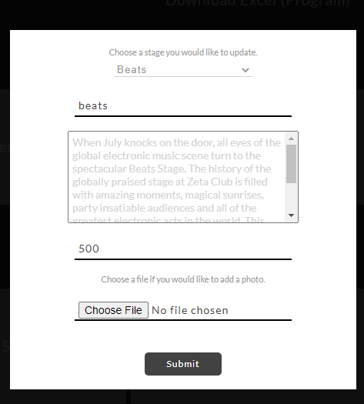

Update vrednsoti se automatski popunjavaju nakon odabira sta zeli da se menja.

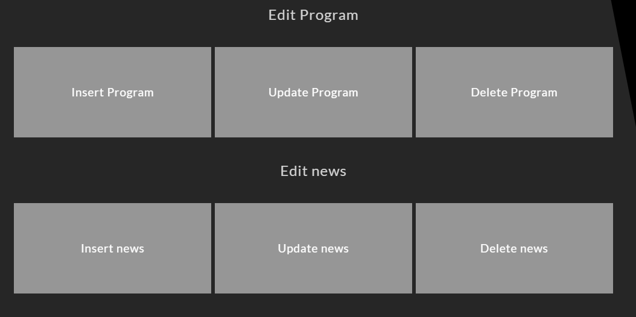

## 2.2 Struktura sajta



Assets

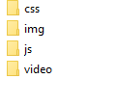

Config

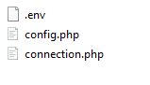

Data



Models

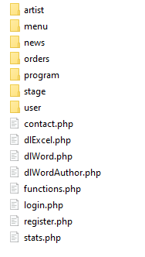

Models/Artist

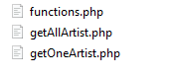

Models/Menu

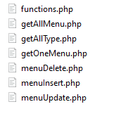

Models/News

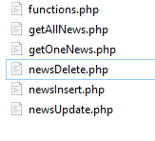

Models/Orders



Models/Program

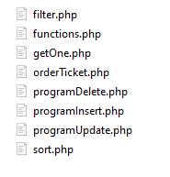

Models/Stage

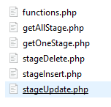

Models/User



Views

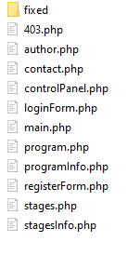

Views/fixed



# 3 KODOVI

## 3.1 PHP views

### 3.11 index.php

<?php

require_once "config/connection.php";

include "views/fixed/head.php";

include "views/fixed/menu.php";

include "models/stage/functions.php";

include "models/program/functions.php";

include "models/orders/functions.php";

include "models/artist/functions.php";

include "models/news/functions.php";

if(!isset($_GET['page'])){

    include "views/main.php";

}

else{

    switch($_GET['page']){

        case 'register':

            include "views/registerForm.php";

        break;

        case 'login':

            include "views/loginForm.php";

        break;

        case 'controlpanel':

            include "views/controlPanel.php";

        break;

        case 'program':

            include "views/program.php";

        break;

        case 'author':

            include "views/author.php";

        break;

        case 'stages':

            include "views/stages.php";

        break;

        case 'contact':

            include "views/contact.php";

        break;

    }

}

if(isset($_GET['page'])){

    if(($_GET['page']!='controlpanel')&&($_GET['page']!='login')&&($_GET['page']!='register')&&($_GET['page']!='author')){

        include "views/fixed/news.php";

    }

}

else{

    include "views/fixed/news.php";

}

include "views/fixed/footer.php";

?>

### 3.12 views

#### 3.121 controlPanel

<?php if(!isset($_SESSION['role'])||($_SESSION['role']!='1')){

    include "views/403.php";

}

$stages = getAllStageGrouped();

$artists = getAllArtist();

$programs = getAllProgram();

?>

<div class="main" id="controlPanel">

    <h1>CONTROL PANEL</h1><br><br><br>

    <a href="models/dlExcel.php" class="dl">Download Excel (Program)</h3><br><br>

    <div id="excelResult"></div>

    <!--edit menu-->

        <h2>Edit Menu</h2>

        <div id="menuEdit" class="cpBlock">

            <!--insert menu-->

            <h3 id="menuInsert">Insert Menu Link</h3>

            <div class="editForm" id="menuInsertBlock">

                <div class="close">

                    <span></span>

                    <span></span>

                </div>

                <form action="models/menu/menuInsert.php" method="POST"  name="formMenuInsert" onsubmit="return proveraMenuInsert()">

                    <div>

                        <?php

                        if(isset($_GET['menuI'])){

                            if(($_GET['menuI']=='invalid')){

                                echo "<p style='color: red'>Menu insert failed</p>";

                            }

                            else if(($_GET['menuI']=='success')){

                                echo "<p style='color: red'>Menu insert success</p>";

                            }

                        }

                        ?>

                    </div>

                    <div><input type="text" id="nameMenuInsert" name="nameMenuInsert" placeholder="Name"/></div>

                    <div><input type="text" id="linkMenuInsert" name="linkMenuInsert" placeholder="Link"/></div>

                    <div><input type="text" id="levelMenuInsert" name="levelMenuInsert" placeholder="Level"/></div>

                    <div>

                        <select id="typeInsertSelect" name="typeInsertSelect">

                            <option value='0'>Type options</option>

                                <?php

                                    $types = types();

                                    foreach ($types as $row) {

                                        $title = $row['type'];

                                        echo "<option value='{$title}'>{$title}</option>";

                                    }

                                ?>

                        </select>

                    </div>

                    <div><p style="font-size: 11px;">If the new menu link has a parent category, please select one of the following.</p></div>

                    <div>

                        <select id="menuParentInsertSelect" name="menuParentInsertSelect">

                            <option value='0'>Menu options</option>

                                <?php

                                    $menu = allMenu();

                                    foreach ($menu as $row) {

                                        $name = $row['name'];

                                        $id = $row['id_menu'];

                                        echo "<option value='{$id}'>{$name}</option>";

                                    }

                                ?>

                        </select>

                    </div>

                    <div class="errorsBlock" id="errorsMenuInsert">

                    </div>

                    <div><input type="submit" name="menuInsertSubmit"></div>

                </form>

            </div>

            <!--------------->

            <!--update menu-->

            <h3 id="menuUpdate">Update Menu Link</h3>

            <div class="editForm" id="menuUpdateBlock">

                <div class="close">

                    <span></span>

                    <span></span>

                </div>

                <form action="models/menu/menuUpdate.php" method="POST"  name="formMenuUpdate" onsubmit="return proveraMenuUpdate()">

                    <div>

                        <?php

                        if(isset($_GET['menuU'])){

                            if(($_GET['menuU']=='invalid')){

                                echo "<p style='color: red'>Menu update failed</p>";

                            }

                            else if(($_GET['menuU']=='success')){

                                echo "<p style='color: red'>Menu update success</p>";

                            }

                        }

                        ?>

                    </div>

                    <div><p style="font-size: 11px;">Select which menu link you would like to change.</p></div>

                    <div>

                        <select id="menuUpdateSelect" name="menuUpdateSelect">

                            <option value='0'>Menu options</option>

                                <?php

                                    $menu = allMenu();

                                    foreach ($menu as $row) {

                                        $name = $row['name'];

                                        $id = $row['id_menu'];

                                        echo "<option value='{$id}'>{$name}</option>";

                                    }

                                ?>

                        </select>

                    </div>

                    <div id="menuUpdateStructure" class="dispFlexColumn"></div>

                </form>

            </div>

            <!--------------->

            <!--delete menu-->

            <h3 id="menuDelete">Delete Menu Link</h3>

            <div class="editForm" id="menuDeleteBlock">

                <div class="close">

                    <span></span>

                    <span></span>

                </div>

                <form action="models/menu/menuDelete.php" method="POST"  name="formMenuDelete" onsubmit="return proveraMenuDelete()">

                    <div>

                        <?php

                        if(isset($_GET['menuD'])){

                            if(($_GET['menuD']=='invalid')){

                                echo "<p style='color: red'>Menu delete failed</p>";

                            }

                            else if(($_GET['menuD']=='success')){

                                echo "<p style='color: red'>Menu delete success</p>";

                            }

                        }

                        ?>

                    </div>

                    <div><p style="font-size: 11px;">Select which menu link you would like to delete.</p></div>

                    <div>

                        <select id="menuDeleteSelect" name="menuDeleteSelect">

                            <option value='0'>Menu options</option>

                                <?php

                                    $menu = allMenu();

                                    foreach ($menu as $row) {

                                        $name = $row['name'];

                                        $id = $row['id_menu'];

                                        echo "<option value='{$id}'>{$name}</option>";

                                    }

                                ?>

                        </select>

                    </div>

                    <div class="errorsBlock" id="errorsMenuDelete">

                    </div>

                    <div><input type="submit" name="menuDeleteSubmit"></div>

                </form>

            </div>

            <!--------------->

        </div>

    <!------------->

    <!--edit stages-->

        <h2>Edit Stage</h2>

        <div id="stageEdit" class="cpBlock">

            <!--insert stage-->

            <h3 id="stageInsert">Insert Stage</h3>

            <div class="editForm" id="stageInsertBlock">

                <div class="close">

                    <span></span>

                    <span></span>

                </div>

                <form action="models/stage/stageInsert.php" method="POST"  name="formstageInsert" onsubmit="return proveraStageInsert()" enctype="multipart/form-data">

                    <div>

                        <?php

                        if(isset($_GET['stageI'])){

                            if(($_GET['stageI']=='invalid')){

                                echo "<p style='color: red'>Stage insert failed</p>";

                            }

                            else if(($_GET['stageI']=='success')){

                                echo "<p style='color: red'>Stage insert success</p>";

                            }

                        }

                        ?>

                    </div>

                    <div><input type="text" id="nameStageInsert" name="nameStageInsert" placeholder="Name"/></div>

                    <div><input type="text" id="capacityInsert" name="capacityInsert" placeholder="Capacity"/></div>

                    <div><textarea id="descriptionStageInsert" name="descriptionStageInsert" placeholder="Description" ></textarea></div>

                    <div><input type="file" id="stagePhotoInsert" name="stagePhotoInsert"/></div>

                    <div class="errorsBlock" id="errorsStageInsert">

                    </div>

                    <div><input type="submit" name="stageInsertSubmit"></div>

                </form>

            </div>

            <!--------------->

            <!--update stage-->

            <h3 id="stageUpdate">Update Stage</h3>

            <div class="editForm" id="stageUpdateBlock">

                <div class="close">

                    <span></span>

                    <span></span>

                </div>

                <form action="models/stage/stageUpdate.php" method="POST"  name="formstageUpdate" onsubmit="return proveraStageUpdate()" enctype="multipart/form-data">

                    <br>

                    <?php

                        if(isset($_GET['stageU'])){

                            if(($_GET['stageU']=='invalid')){

                                echo "<p style='color: red'>Stage update failed</p>";

                            }

                            else if(($_GET['stageU']=='success')){

                                echo "<p style='color: red'>Stage update success</p>";

                            }

                        }

                        ?>

                    <div><p style="font-size: 11px;">Choose a stage you would like to update.</p></div>

                    <div>

                        <select id="stageUpdateSelect" name="stageUpdateSelect">

                            <option value='0'>Stages</option>

                                <?php

                                    foreach ($stages as $row) {

                                        $name = ucfirst($row['name']);

                                        $id = $row['id_stage'];

                                        echo "<option value='{$id}'>{$name}</option>";

                                    }

                                ?>

                        </select>

                    </div>

                    <div id="stageUpdateStructure" class="dispFlexColumn"></div>

                </form>

            </div>

            <!--------------->

            <!--delete stage-->

            <h3 id="stageDelete">Delete Stage</h3>

            <div class="editForm" id="stageDeleteBlock">

                <div class="close">

                    <span></span>

                    <span></span>

                </div>

                <form action="models/stage/stageDelete.php" method="POST"  name="formstageDelete" onsubmit="return proveraStageDelete()">

                    <br>

                    <?php

                        if(isset($_GET['stageD'])){

                            if(($_GET['stageD']=='invalid')){

                                echo "<p style='color: red'>Stage delete failed</p>";

                            }

                            else if(($_GET['stageD']=='success')){

                                echo "<p style='color: red'>Stage delete success</p>";

                            }

                        }

                        ?>

                    <div><p style="font-size: 11px;">Choose a stage you would like to delete.</p></div>

                    <div>

                        <select id="stageDeleteSelect" name="stageDeleteSelect">

                            <option value='0'>Stages</option>

                                <?php

                                    foreach ($stages as $row) {

                                        $name = ucfirst($row['name']);

                                        $id = $row['id_stage'];

                                        echo "<option value='{$id}'>{$name}</option>";

                                    }

                                ?>

                        </select>

                    </div>

                    <div class="errorsBlock" id="errorsStageDelete">

                    </div>

                    <div><input type="submit" name="stageDeleteSubmit"></div>

                </form>

            </div>

            <!--------------->

        </div>

    <!------------->

    <!--edit program-->

        <h2>Edit Program</h2>

        <div id="programEdit" class="cpBlock">

            <!--insert program-->

            <h3 id="programInsert">Insert Program</h3>

            <div class="editForm" id="programInsertBlock">

                <div class="close">

                    <span></span>

                    <span></span>

                </div>

                <form action="models/program/programInsert.php" method="POST"  name="formprogramInsert" onsubmit="return proveraProgramInsert()" enctype="multipart/form-data">

                    <div>

                        <?php

                        if(isset($_GET['programI'])){

                            if(($_GET['programI']=='invalid')){

                                echo "<p style='color: red'>Program insert failed</p>";

                            }

                            else if(($_GET['programI']=='success')){

                                echo "<p style='color: red'>Program insert success!</p>";

                            }

                        }

                        ?>

                    </div>

                    <div><input type="text" id="nameProgramInsert" name="nameProgramInsert" placeholder="Name"/></div>

                    <div>

                        <textarea id="descProgramInsert" name="descProgramInsert" placeholder="Description"></textarea>

                    </div>

                    <div>

                        <select id="programStageInsertSelect" name="programStageInsertSelect">

                            <option value='0'>Stages</option>

                                <?php

                                    foreach ($stages as $row) {

                                        $name = ucfirst($row['name']);

                                        $id = $row['id_stage'];

                                        echo "<option value='{$id}'>{$name}</option>";

                                    }

                                ?>

                        </select>

                    </div>

                    <div>

                        <select id="artistProgramInsertSelect" name="artistProgramInsertSelect">

                            <option value='0'>Artists</option>

                                <?php

                                    foreach ($artists as $row) {

                                        $name = ucfirst($row['name']);

                                        $id = $row['id_artist'];

                                        echo "<option value='{$id}'>{$name}</option>";

                                    }

                                ?>

                        </select>

                    </div>

                    <div><input type="text" id="priceProgramInsert" name="priceProgramInsert" placeholder="Ticket price"></div>

                    <div><input type="date" id="dateProgramInsert" name="dateProgramInsert">

                    <input type="time" id="timeProgramInsert" name="timeProgramInsert"></div>

                    <div><input type="file" id="programPhotoInsert" name="programPhotoInsert"/></div>

                    <div class="errorsBlock" id="errorsProgramInsert">

                    </div>

                    <div><input type="submit" name="programInsertSubmit"></div>

                </form>

            </div>

            <!--------------->

            <!--update program-->

            <h3 id="programUpdate">Update Program</h3>

            <div class="editForm" id="programUpdateBlock">

                <div class="close">

                    <span></span>

                    <span></span>

                </div>

                <form action="models/program/programUpdate.php" method="POST"  name="formProgramUpdate" onsubmit="return proveraProgramUpdate()" enctype="multipart/form-data">

                    <div>

                        <?php

                        if(isset($_GET['programU'])){

                            if(($_GET['programU']=='invalid')){

                                echo "<p style='color: red'>Program update failed</p>";

                            }

                            else if(($_GET['programU']=='success')){

                                echo "<p style='color: red'>Program update success!</p>";

                            }

                        }

                        ?>

                    </div>

                    <div><p style="font-size: 11px;">Choose a program which you would like to update.</p></div>

                    <div>

                        <select name="idProgramUpdate" id="idProgramUpdate">

                            <option value='0'>Programs</option>

                                <?php

                                    foreach ($programs as $row) {

                                        $name = ucfirst($row['program_name']);

                                        $id = $row['id_program'];

                                        echo "<option value='{$id}'>{$name}</option>";

                                    }

                                ?>

                        </select>

                    </div>

                    <div id="programUpdateStructure" class="dispFlexColumn"></div>

                    <!---->

                </form>

            </div>

            <!--------------->

            <!--delete program-->

            <h3 id="programDelete">Delete Program</h3>

            <div class="editForm" id="programDeleteBlock">

                <div class="close">

                    <span></span>

                    <span></span>

                </div>

                <form action="models/program/programDelete.php" method="POST"  name="formProgramDelete" onsubmit="return proveraProgramDelete()">

                    <br>

                    <?php

                        if(isset($_GET['programD'])){

                            if(($_GET['programD']=='invalid')){

                                echo "<p style='color: red'>Program delete failed</p>";

                            }

                            else if(($_GET['programD']=='success')){

                                echo "<p style='color: red'>Program delete success.</p>";

                            }

                        }

                        ?>

                        <div><p style="font-size: 11px;">Choose a program you would like to update.</p></div>

                    <div>

                        <select name="nameProgramDelete" id="nameProgramDelete">

                            <option value='0'>Programs</option>

                                <?php

                                    foreach ($programs as $row) {

                                        $name = ucfirst($row['program_name']);

                                        $id = $row['id_program'];

                                        echo "<option value='{$id}'>{$name}</option>";

                                    }

                                ?>

                        </select>

                    </div>

                    <div class="errorsBlock" id="errorsProgramDelete">

                    </div>

                    <div><input type="submit" name="programDeleteSubmit"></div>

                </form>

            </div>

            <!--------------->

        </div>

    <!------------->

</div>

#### 3.122 main

<?php

    $program = getCustomProgram("date", 3, 0);

?>

<div class="main">

    <div class="mainBlock">

        <div><h3><?php if(isset($_GET['dlword'])&&$_GET['dlword']=='success') echo 'Download successful!' ?></h3></div><br>

        <div><h3><?php if(isset($_GET['log'])&&($_GET['log']=='success')) echo "<div id='formSuccess'><p>Login complete!</p></div>"; ?></h3></div><br>

        <div><h3><?php if(isset($_GET['reg'])&&($_GET['reg']=='success')) echo "<div id='formSuccess'><p>Registration complete!</p></div>"; ?></h3></div><br>

        <div id="video">

            <video autoplay loop muted>

            <source src="assets/video/video.mp4" type="video/mp4">

        </video>

        </div>

        <h1>Welcome to <span>ZETA</span></h1>

        <hr/>

        <h2>Coming Up</h2>

        <div class="threeBlockHolder">

            <?php foreach($program as $row):

                $name = $row['program_name'];

                $cover = $row['cover'];

                $date = $row['date'];

                $id = $row['id_program_artist'];

                ?>

                <div class="threeBlockChild programChild">

                    <a href="index.php?page=program&id=<?= $id ?>">

                        <img src="<?= 'assets/img/program/'.$cover?>" alt="<?= $name?>"/>

                        <div id="title">

                            <h2><?= $name?></h2>

                            <p><?= $date?></p>

                        </div>

                    </a>

                </div>

            <?php endforeach;?>

        </div>

        <br>

        <div class="readMore">

            <a href="index.php?page=program">See More</a>

        </div>

        <hr/>

    </div>

</div>

#### 3.123 loginForm

<div class="formBlock main">

    <form method="POST" action="models/login.php" id="formLogin" onsubmit="return proveraLogin()">

        <div><h4>Log In</h4></div>

        <?php

            if((isset($_GET['log']))&&($_GET['log']!='success')){

                $username = $_GET['username'];

                echo "<div><input type='text' name='usernameLogin' id='usernameLogin' value='{$username}'/></div>";

            }

            else{

                echo "<div><input type='text' name='usernameLogin' id='usernameLogin' placeholder='Username'/></div>";

            }

        ?>

        <div><input type="password" name="passwordLogin" id="passwordLogin" placeholder="Password"/></div>

        <div class='redirectSignInRegister'><p>Don't have an account?</p>&nbsp;<a href="index.php?page=register">Register here.</a></div>

        <div class='errorsBlock' id='loginErrorsBlock'>

            <?php

                if(isset($_GET['log'])){

                    $err = $_GET['log'];

                    if($err=='invalid'){

                        echo "<div class='error'><p>Data not in right format.</p></div>";

                    } else if($err=='notexists'){

                        echo "<div class='error'><p>Username doesn't exist.</p></div>";

                    } else if($err=='nomatch'){

                        echo "<div class='error'><p>Username and password don't match.</p></div>";

                    }

                }

            ?>

        </div>

        <div><input type="submit" name="dugmeLogin" id="dugmeLogin" value="Continue"></div>

    </form>

</div>

#### 3.124 registerForm

<div class="formBlock main">

    <?php if(isset($_GET['reg'])){

        if($_GET['reg']=='success'){

            echo "<div id='formSuccess'><p>Registration complete!</p></div>";

        }

    } ?>

    <form method='POST' action="models/register.php"  id='formRegister' onsubmit='return proveraRegister()'>

        <div><h4>Create An Account</h4></div>

        <?php

        if((isset($_GET['reg']))&&($_GET['reg']!='success')){

            $firstName = $_GET['firstName'];

            $lastName = $_GET['lastName'];

            $username = $_GET['username'];

            $email = $_GET['email'];

            echo "<div><input type='text' name='firstName' id='firstName' placeholder='First Name' value='$firstName'/></div>

            <div><input type='text' name='lastName' id='lastName' placeholder='Last Name' value='$lastName'/></div>

            <div><input type='text' name='usernameRegister' id='usernameRegister' value='$username'/></div>

            <div><input type='email' name='emailRegister' id='emailRegister' value='$email'/></div>";

        }

        else{

            echo "<div><input type='text' name='firstName' id='firstName' placeholder='First Name'/></div>

            <div><input type='text' name='lastName' id='lastName' placeholder='Last Name'/></div>

            <div><input type='text' name='usernameRegister' id='usernameRegister' placeholder='Username'/></div>

            <div><input type='text' name='emailRegister' id='emailRegister' placeholder='Email'/></div>";

        }

        ?>

        <div><input type='password' name='passwordRegister' id='passwordRegister' placeholder='Password'/></div>

        <div><input type='password' name='passwordConfirm' id='passwordConfirm' placeholder='Confirm Password'/></div>

        <div class='redirectSignInRegister'><p>Already have an account?</p>&nbsp;<a href='index.php?page=login'>Log in here.</a></div>

        <div class='errorsBlock' id='registerErrorsBlock'>

            <?php

            if(isset($_GET['reg'])){

                if($_GET['reg']=='error'){

                    echo '<div class="error"><p>Registration failed.</p></div>';

                }

                if($_GET['reg']=='username'){

                    echo '<div class="error"><p>Username already exists.</p></div>';

                }

                else if($_GET['reg']=='email'){

                    echo '<div class="error"><p>Email already exists.</p></div>';

                }

            }

        ?>

        </div>

        <div><input type='submit' name='dugmeRegister' id='dugmeRegister' value='Continue'></div>

    </form>

</div>

#### 3.125 author

<div class="main" id="author">

        <div class="wrapper">

            <h1>Author</h1>

            <div><h3><?php if(isset($_GET['dlword'])&&$_GET['dlword']=='success') echo 'Download successful!' ?></h3></div><br>

            <div>

                <img src="assets/img/author.jpg" alt="author" />

            </div>

            <div id="authorDescription">

                <p>My name's Teodora Nedeljković. In 2018 I entered ICT College of Vocational Studies. I was first introduced to web design here and since the start have been trying my best to become an amazing Front End Developer.</p><br><br>

                <p>Check out my portfolio <a href="#">here.</a></p><br>

                <a href="models/dlWordAuthor.php" >Download Word</a>

            </div>

        </div>

    </div>

#### 3.126 program

<?php

    $stages = getAllStageGrouped();

    if(!isset($_GET['num'])){

        $program = getCustomProgram('date', 6, 0);

    }

    else{

        $num = $_GET['num'];

        $program = paginate('date', 6, $num);

    }

?>

<div id="program" class="main">

        <?php if(isset($_GET['id'])):

            include "programInfo.php";

        else:

        ?>

        <div class="sort">

            <select id="sortProgram">

                <option value="0">Sort By</option>

                <option value="newest">Newest</option>

                <option value="oldest">Oldest</option>

                <option value="A-Z">A-Z</option>

                <option value="Z-A">Z-A</option>

            </select>

            <select id="filterProgram">

                <option value="0">Choose a stage</option>

                <?php

                foreach($stages as $row){

                    $name = ucfirst($row['name']);

                    $id = $row['id_stage'];

                    echo "<option value='$id'>$name</option>";

                }

                ?>

            </select>

        </div>

        <div class="twoBlockHolder" id="twoBlockHolderProgram">

            <?php $i = 1; ?>

            <?php foreach($program as $row):

                $name = $row['program_name'];

                $cover = $row['cover'];

                $date = $row['date'];

                $id = $row['id_program_artist'];

            ?>

            <div class="twoBlockChild programChild">

                <a href="index.php?page=program&id=<?= $id ?>">

                    <img src="<?= 'assets/img/program/'.$cover?>" alt="<?= $name?>"/>

                    <div id="title">

                        <h2><?= $name?></h2>

                        <p><?= $date?></p>

                    </div>

                </a>

            </div>

            <?php endforeach;?>

        </div>

        <div class="pagination">

            <?php

            $pagesInTotal = pagesInTotal(6);

            for($i = 1; $i <= $pagesInTotal; $i++){

                echo "<a href='index.php?page=program&num={$i}'>{$i}</a>";

            }

            ?>

        </div>

    <?php endif; ?>

</div>

#### 3.127 programInfo

<?php

    $id = $_GET['id'];

    $one = getOneProgram($id);

    $date = $one['date'];

    $programName= $one['program_name'];

    $artistName = $one['name'];

    $desc = $one['program_description'];

    $programCover = $one['cover'];

    $artistPhoto = $one['photo'];

    $priceId = $one['id_price'];

    $price = $one['price'];

    $stageId = $one['stage_id'];

    $stageCapacity = getOneStage($stageId)['capacity'];

    $programsOrdered = count(getCountProgramOrders($id));

?>

<div id="infoProgram">

    <div id="title">

        <h1><?= $programName ?></h1>

        <p><?= formatDate($date)?></p>

    </div>

    <hr/>

    <div id="artistProgram" class="childInfo">

        <h2>Playing For You<br> <span><?= $artistName ?></span></h2>

        <div id="artistPhoto">

            <img src="<?= 'assets/img/artist/'.$artistPhoto ?>" alt="<?= $artistName ?>"/>

        </div>

    </div>

    <hr/>

    <div id="programBlock" class="childInfo">

        <div>

            <img src="<?= 'assets/img/program/'.$programCover ?>" alt="<?= $programName ?>"/>

        </div>

        <p><?= $desc ?></p>

    </div>

    <?php if(!isset($_SESSION['username'])): ?>

        <div id="loginHere"><p>Log in to order a ticket <a href="index.php?page=login">here</a></p></div>

    <?php elseif($stageCapacity < $programsOrdered): ?>

        <div><p>Sorry, all the tickets have been bought.</p></div>

    <?php else: ?>

        <h3 id="orderTicket">Order Ticket</h3>

        <div class="editForm" id="orderTicketBlock">

                <div class="close">

                    <span></span>

                    <span></span>

                </div>

                <form action="<?= "models/program/orderTicket.php" ?>" method="POST" onsubmit=" return proveraOrderTicket()">

                    <div><p id="ticketPrice">Ticket price: <?= $price ?>$</p id="ticketPrice"></div>

                    <div><select id="orderTicketSelect" name="orderTicketSelect">

                        <option value="0">Number of tickets</option>

                        <option value="1">1</option>

                        <option value="2">2</option>

                        <option value="3">3</option>

                        <option value="4">4</option>

                        <option value="5">5</option>

                    </select></div>

                    <input type="hidden" name="urlAddress" value="<?=$_SERVER['REQUEST_URI'] ?>" />

                    <input type="hidden" name="programId" value="<?= $id ?>" />

                    <input type="hidden" name="programName" value="<?= $programName ?>" />

                    <div class="errorsBlock" id="errorsOrderTicket"></div>

                    <div><input type="submit" name="orderTicketSubmit" id="orderTicketSubmit" value="Order Ticket" /></div>

                </form>

        </div>

    <?php endif; ?>

</div>

#### 3.128 stagesInfo

<?php

    $id = $_GET['id'];

    $stage = getOneStageWithPhotos($id);

    $name = $stage[0]['name'];

    $desc = $stage[0]['stage_description'];

    $capacity = $stage[0]['capacity'];

    //$photo = $stage['photo'];

    //var_dump($stage)

?>

<div id="stageInfo">

    <div id="title">

        <h1><?= strtoupper($name) ?></h1>

    </div>

    <div class="coverStagePhoto">

        <img src="<?= "assets/img/stage/".$stage[0]['photo'] ?>" alt="<?=$name?>">

    </div>

    <div id="desc">

        <p><?php echo $desc ?></p>

        <p>Capacity: <?php echo $capacity?> people</p>

    </div>

    <div class="photosStage">

        <?php foreach($stage as $key=>$value):

            if($key!=0):

                $photo = $value['photo'];

            ?>

            <img data-src="<?= $photo?>" src="<?= "assets/img/stage/".$photo ?>" alt="<?=$name?>">

        <?php endif; ?>

    <?php endforeach;?>

    <div id="magnifiedPhoto">

    </div>

    </div>

</div>

#### 3.129 stages

<?php

    $stages = getAllStageGrouped();

?>

<div class="main" id="stages">

    <?php if(isset($_GET['id'])):

            include "stagesInfo.php";

        else:

            ?>

        <div id="bgStage"></div>

        <div id="mainTitle">

            <h1>STAGES</h1>

            <hr/>

        </div>

        <?php foreach($stages as $row):

            $id = $row['id_stage'];

            $name = $row['name'];

            $photo = $row['photo'];

        ?>

            <div class="stageChild">

                <img src="assets/img/stage/<?= $photo?>" alt="<?= $name ?>"/>

                <a id="darkOver" href=<?= "index.php?page=stages&id=".$id ?>>

                    <h2><?= $name?></h2>

                </a>

            </div>

        <?php endforeach;?>

    <?php endif; ?>

</div>

#### 3.1210 contact

<div id="contactBlock" class="formBlock main">

                <form method="POST" action="models/contact.php" name="" id="formContact" onsubmit="return proveraContact()">

                    <?php

                        if(isset($_GET['msg'])){

                            $msg = $_GET['msg'];

                            if($msg=='success'){

                                echo "<br/><p style='color: #fac864'>Successfully sent!</p><br>";

                            } else if($msg=='invalid'){

                                echo "<br/><p style='color: #fac864'>Invalid format!</p><br>";

                            }

                        }

                    ?>

                    <div><h4>Contact the administrator</h4></div>

                    <div><input type="text" name="fullNameContact" id="fullNameContact" placeholder="Full Name"/></div>

                    <div><input type="text" name="subjectContact" id="subjectContact" placeholder="Subject" placeholder="Your message..." /></div>

                    <div>

                        <textarea id="messageContact" name="messageContact" placeholder="Your message..."></textarea>

                    </div>

                    <div id="dugmeProveraContact"><input type="submit" name="dugmeContact" id="dugmeContact" value="Continue"></div>

                    <div id="contactError" class="errorsBlock">

                    </div>

                </form>

</div>

## 3.2 PHP models

### 3.21 contact.php

<?php

    require "../config/connection.php";

    if(isset($_POST['dugmeContact'])){

        $errors = array();

        $fullName = $_POST['fullNameContact'];

        $subject = $_POST['subjectContact'];

        $msg = $_POST['messageContact'];

        $regexFullName = "/^[A-Z][a-z]{2,20}(\s[A-Z][a-z]{2,20})+$/";

        $regexSubject = "/^[\w\d]{1,30}$/";

        $regexMessage = "/^.{5,150}$/";

        if(!preg_match($regexFullName,$fullName)){

            array_push($errors,'Name in invalid format.');

        }

        if(!preg_match($regexSubject,$subject)){

            array_push($errors, 'Subject in invalid format.');

        }

        if(!preg_match($regexMessage,$msg)){

            array_push($errors, 'Message in invalid format.');

        }

        if(count($errors)==0){

            $adminEmail = execQuery("SELECT email FROM club.user WHERE role_id = 1");

            mail($adminEmail,$subject,$msg);

            header('Location: ../index.php?page=contact&msg=success');

        }

        else{

            header('Location: ../index.php?page=contact&msg=invalid');

        }

    }

?>

### 3.22 dlExcel.php

<?php

require_once "../config/connection.php";

include "program/functions.php";

include "stage/functions.php";

$today = date('Y-m-d');

$path = "D:\\zeta_program.xls";

$program = getProgramWhere('date',4143,0,"date>$today");

    /*if(file_exists($path)){

            $excelApp = new COM("excel.application") or die("fail");

            $workbook = $excelApp->Workbooks->Open($path) or die("fail");

            $worksheet = $workbook->Worksheets("Sheet1");

            $worksheet->activate;

            $rowNum = 1;

            foreach($program as $row){

                $rowNum +=1;

                $name = $row['program_name'];

                $stage = ucfirst(getOneStage($row['stage_id'])['name']);

                $price = getOneProgram($row['id_program'])['price'];

                $artist = $row['name'];

                $date = $row['date'];

                $cell = $worksheet->Range('A'.$rowNum);

                $cell->activate;

                $cell->Value = $name;

                $cell = $worksheet->Range("B".$rowNum);

                $cell->activate;

                $cell->Value = $stage;

                $cell = $worksheet->Range("C".$rowNum);

                $cell->activate;

                $cell->Value = $artist;

                $cell = $worksheet->Range("D".$rowNum);

                $cell->activate;

                $cell->Value = $date;

                $cell = $worksheet->Range("E".$rowNum);

                $cell->activate;

                $cell->Value = $price."$";

            }

            $cell = $worksheet->Range("F1");

            $cell->activate;

            $cell->Value = $rowNum;

            $workbook->Save();

            $workbook->Saved = true;

            $workbook->Close;

            unset($workbook);

            unset($worksheet);

            $excelApp->Workbooks->Close();

            $excelApp->Quit();

            unset($excelApp);

    }

    else{

            $excelApp = new COM("Excel.application") or die('fail');

            $workbook = $excelApp ->Workbooks-> Add();

            $worksheet = $workbook->Worksheets("Sheet1");

            $cell = $worksheet->Range("A1");

            $cell->activate;

            $cell->Value = "Program Name:";

            $cell = $worksheet->Range("B1");

            $cell->activate;

            $cell->Value = "Stage Name:";

            $cell = $worksheet->Range("C1");

            $cell->activate;

            $cell->Value = "Artist Name:";

            $cell = $worksheet->Range("D1");

            $cell->activate;

            $cell->Value = "Date:";

            $cell = $worksheet->Range("E1");

            $cell->activate;

            $cell->Value = "Ticket price:";

            $cell = $worksheet->Range("F1");

            $cell->activate;

            $cell->Value = 1;

            $rowNum = $cell->Value;

            foreach($program as $row){

                $rowNum+=1;

                $name = $row['program_name'];

                $stage = ucfirst(getOneStage($row['stage_id'])['name']);

                $price = getOneProgram($row['id_program'])['price'];

                $artist = $row['name'];

                $date = $row['date'];

                $cell = $worksheet->Range('A'.$rowNum);

                $cell->activate;

                $cell->Value = $name;

                $cell = $worksheet->Range("B".$rowNum);

                $cell->activate;

                $cell->Value = $stage;

                $cell = $worksheet->Range("C".$rowNum);

                $cell->activate;

                $cell->Value = $artist;

                $cell = $worksheet->Range("D".$rowNum);

                $cell->activate;

                $cell->Value = $date;

                $cell = $worksheet->Range("E".$rowNum);

                $cell->activate;

                $cell->Value = $price."$";

            }

            $cell = $worksheet->Range("F1");

            $cell->activate;

            $cell->Value = $rowNum;

            $workbook->_SaveAs("$path", -4143);

            $workbook->Save();

            $workbook->Saved = true;

            $workbook->Close;

            $excelApp->Workbooks->Close();

            $excelApp->Quit();

            unset($worksheet);

            unset($workbook);

            unset($excelApp);

    }*/

$str = '';

$str .= "<table>

                <tr>

                    <td>Program</td>

                    <td>Stage</td>

                    <td>Price</td>

                    <td>Artist</td>

                    <td>Date</td>

                </tr>";

    foreach($program as $row){

        $name = $row['program_name'];

        $stage = ucfirst(getOneStage($row['stage_id'])['name']);

        $price = getOneProgram($row['id_program'])['price'];

        $artist = $row['name'];

        $date = $row['date'];

        $str .= "<tr>

                <td>$name</td>

                <td>$stage</td>

                <td>$price</td>

                <td>$artist</td>

                <td>$date</td>

                </tr>";

    }

header("Content-type: application/xls");

header("Content-Disposition: attachment;Filename=zeta_programi.xls");

echo $str;

### 3.23 dlWord.php

<?php

//header("Location: ../index.php?dlword=success");

    include "../config/connection.php";

    include "orders/functions.php";

    include "user/functions.php";

    include "program/functions.php";

    session_start();

    $username = $_SESSION['username'];

    $userId = getOneUser($username)['id_user'];

    $orders = getUserOrders($userId);

    $path = $path = "D:\\zeta_orders.docx";

    /*$wordApp = new COM("Word.application") or die('fail');

    $wordApp->Visible = true;

    $wordApp->Documents->Add();

    foreach($orders as $row){

        $programId = $row['id_program'];

        $programName = getOneProgram($programId)['program_name'];

        $price = getOneProgram($programId)['price'];

        $ticketsQuantity = $row["ticketsQuantity"];

        $date = $row["orders_date"];

        $wordApp->Selection->TypeText("Program Name: $programName\n");

        $wordApp->Selection->TypeText("Price: $price $\n");

        $wordApp->Selection->TypeText("Tickets Quantity: $ticketsQuantity\n");

        $wordApp->Selection->TypeText("Date Ordered: $date\n");

        $wordApp->Selection->TypeText("\n");

    }

    $wordApp->Selection->TypeText("Ordered by: $username\n");

    $wordApp->Documents[1]->SaveAs("$path");

    $wordApp->Quit();

    $wordApp = null;*/

    header("Content-type: application/vnd.ms-word");

    header("Content-Disposition: attachment;Filename=orders.doc");

    echo "<html>";

    echo "<body>";

    echo "<i>Orders</i>";

    foreach($orders as $row){

        $programId = $row['id_program'];

        $programName = getOneProgram($programId)['program_name'];

        $price = getOneProgram($programId)['price'];

        $ticketsQuantity = $row["ticketsQuantity"];

        $date = $row["orders_date"];

        echo "<p>Program Name: $programName</p>";

        echo "<p>Price: $price</p>";

        echo "<p>Tickets Quantity: $ticketsQuantity</p>";

        echo "<p>Date Ordered: $date</p>";

        echo "<br>";

    }

    echo "</body>";

    echo "</html>";

### 3.24 dlWordAuthor.php

<?php

    //include "../config/connection.php";

    /*$path = $path = "D:\\zeta_author.docx";

    $wordApp = new COM("Word.application") or die('fail');

    $wordApp->Visible = true;

    $wordApp->Documents->Add();

        $wordApp->Selection->TypeText("Name: Teodora Nedeljkovic\n");

        $wordApp->Selection->TypeText("Index: 5/18\n");

        $wordApp->Selection->TypeText("College: ICT College of Vocational Studies\n");

        $wordApp->Selection->TypeText(" Bio: I was first introduced to web design at my college and since the start have been trying my best to become an amazing Front End Developer.\n");

    $wordApp->Documents[1]->SaveAs("$path");

    $wordApp->Quit();

    $wordApp = null;*/

header("Content-type: application/vnd.ms-word");

header("Content-Disposition: attachment;Filename=autor.doc");

echo "<html>";

echo "<body>";

echo "<i>Author</i>";

echo "<p>My name's Teodora Nedeljkovic. In 2018 I entered ICT College of Vocational Studies.<br> I was first introduced to web design here and since the start have been trying my best<br> to become an amazing Front End Developer.<br>Check out my portfolio here.</p>";

echo "<p>College: ICT College of Vocational Studies</p>";

echo "<p>Year of studying: second</p>";

echo "</body>";

echo "</html>";

### 3.25 fucntions.php

<?php

function pageEntry(){

    $file = fopen(LOG_FILE,'ab');

    if($file){

        $page = $_SERVER['REQUEST_URI'];

        $date = date('d-m-Y H:i:s');

        $ipAddr = $_SERVER['REMOTE_ADDR'];

        fwrite($file, $page.SEPARATOR.$ipAddr.SEPARATOR.$date."\n");

        fclose($file);

    }

}

//general

function formatDate($date){

    return @date('j  M, Y', mktime($date));

}

function writeLoginError($username){

    $file = fopen(ERR_FILE,'ab');

    if($file){

        $page = $_SERVER['REQUEST_URI'];

        $date = date('d-m-Y H:i:s');

        $ipAddr = $_SERVER['REMOTE_ADDR'];

        fwrite($file, $username.SEPARATOR.$ipAddr.SEPARATOR.$date."\n");

        fclose($file);

    }

}

//sort

function compareOldest($a, $b){

    if($a['date'] > $b['date']) return -1;

    if($a['date'] < $b['date']) return 1;

    if($a['date'] == $b['date']) return 0;

}

function compareAZ($a, $b){

    if($a['name'] > $b['name']) return 1;

    if($a['name'] < $b['name']) return -1;

    if($a['name'] == $b['name']) return 0;

}

function compareZA($a, $b){

    if($a['name'] > $b['name']) return -1;

    if($a['name'] < $b['name']) return 1;

    if($a['name'] == $b['name']) return 0;

}

function compareNewest($a, $b){

    if($a['date'] > $b['date']) return 1;

    if($a['date'] < $b['date']) return -1;

    if($a['date'] == $b['date']) return 0;

}

### 3.26 login.php

<?php

    require "../config/connection.php";

    if(isset($_POST['dugmeLogin'])){

        $errors = array();

        $regexUser = "/^(?=.*[A-z])(?!\s)[A-z\d\.]{3,25}$/";

        $regexPassword = "/^(?=.*[a-z])(?=.*\d)(?=.*[A-Z]).{3,30}$/";

        $username = $_POST['usernameLogin'];

        $password = $_POST['passwordLogin'];

        if(!preg_match($regexUser,$username)){

            array_push($errors,'Username in invalid format');

        }

        if(!preg_match($regexPassword,$password)){

            array_push($errors,'Password in invalid format');

        }

        if(count($errors)!=0){

            header("Location: ../index.php?page=login&log=invalid&username=$username");

            exit();

        }

        else{

            $selUser = $conn->prepare("SELECT * FROM club.user WHERE username=:user");

            $selUser->bindParam(":user", $username);

            $selUser->execute();

            if($selUser->rowCount()!=1){

                header("Location: ../index.php?page=login&log=notexists&username=$username");

                exit();

            }

            else{

                $password = md5($password);

                $selPass = $conn->prepare("SELECT * FROM club.user WHERE username=:user AND password=:pass");

                $selPass->bindParam(":user", $username);

                $selPass->bindParam(":pass", $password);

                $selPass->execute();

                if($selPass->rowCount()!=1){

                    header("Location: ../index.php?page=login&log=nomatch&username=$username");

                    writeLoginError($username);

                    exit();

                }

                else{

                    session_start();

                    $result = $selPass->fetch();

                    $_SESSION['username'] = $username;

                    $_SESSION['role'] = $result['role_id'];

                    header('Location: ../index.php?&log=success');

                    exit();

                }

            }

        }

    }

?>

### 3.27 register.php

<?php

require_once "../config/connection.php";

if(isset($_POST['dugmeRegister'])){

    echo 'this';

    $errors = array();

    $regexFirstName = "/^[A-Z][a-z]{2,30}(\s[A-Z][a-z]{2,30})*$/";

    $regexLastName = "/^[A-Z][a-z]{2,30}(\s[A-Z][a-z]{2,30})*$/";

    $regexUser = "/^(?=.*[A-z])(?!\s)[A-z\d\.]{3,25}$/";

    $regexEmail = "/^([A-z][A-z0-9-._]{2,35})\@([A-z]{3,10}\.[a-z]{2,5}(.[a-z]{2,5})?)$/";

    $regexPassword = "/^(?=.*[a-z])(?=.*\d)(?=.*[A-Z]).{3,30}$/";

    $firstName = $_POST['firstName'];

    $lastName = $_POST['lastName'];

    $username = $_POST["usernameRegister"];

    $email = $_POST["emailRegister"];

    $password = $_POST["passwordRegister"];

    $passwordConfirm = $_POST["passwordConfirm"];

    if(!preg_match($regexFirstName,$firstName)){

        array_push($errors,'First name invalid');

    }

    if(!preg_match($regexLastName,$lastName)){

        array_push($errors,'Last name invalid');

    }

    if(!preg_match($regexUser,$username)){

        array_push($errors,'Username invalid');

    }

    if(!preg_match($regexEmail,$email)){

        array_push($errors,'Email invalid');

    }

    if(!preg_match($regexPassword,$password)){

        array_push($errors,'Password has to contain one lc letter, uc letter and a number');

    }

    if($password!=$passwordConfirm){

        array_push($errors,"Passwords don't match");

    }

    if(count($errors)!=0){

        header("Location: ../index.php?page=register&reg=error&firstName=$firstName&lastName=$lastName&email=$email&username=$username");

    }

    else{

        $password = md5($password);

        $sel = $conn->prepare("SELECT username,email FROM club.user WHERE username=:user OR email=:email");

        $sel->bindParam(":user",$username);

        $sel->bindParam(":email",$email);

        $sel->execute();

        $result= $sel->fetchAll();

        if(count($result)>0){

            foreach($result as $element){

                if($element['username']==$username){

                    header("Location: ../index.php?page=register&reg=username&firstName=$firstName&lastName=$lastName&email=$email&username=$username");

                    exit();

                }

                if($element['email']==$email){

                    header("Location: ../index.php?page=register&reg=email&firstName=$firstName&lastName=$lastName&email=$email&username=$username");

                    exit();

                }

            }

        }

        else{

            $insert = $conn->prepare("INSERT INTO club.user(first_name,last_name,username,email,password) VALUES (:fName,:lName,:user,:email,:pass)");

            $insert->bindParam(":fName", $firstName);

            $insert->bindParam(":lName", $lastName);

            $insert->bindParam(":user", $username);

            $insert->bindParam(":pass", $password);

            $insert->bindParam(":email", $email);

            $insert->execute();

            if($insert->rowCount()==1){

                session_start();

                $_SESSION['username'] = $username;

                $_SESSION['role'] = 2;

                header('Location: ../index.php?reg=success');

            }

            else{

                header("Location: ../index.php?page=register&reg=error&firstName=$firstName&lastName=$lastName&email=$email&username=$username");

            }

        }

    }

}

?>

### 3.28 artist/functions.php

<?php

/*function getOneProgram($id){

    return execQuery("SELECT * FROM club.program p INNER JOIN club.program_artist pa ON p.id_program = pa.id_program INNER JOIN club.artist a ON pa.id_artist = a.id_artist INNER JOIN club.price pr ON pr.id_program = p.id_program WHERE p.id_program = $id ORDER BY price_date DESC LIMIT 1")[0];

}*/

function getAllArtist(){

    return execQuery("SELECT * FROM club.artist");

}

?>

### 3.29 artist/getAllArtist.php

<?php

require "../../config/connection.php";

    header('Content-Type: application/json');

    $arr = execQuery("SELECT * FROM club.artist");

    if($arr){

        echo json_encode($arr,JSON_UNESCAPED_UNICODE);

        http_response_code(200);

    }

    else{

        http_response_code(500);

    }

### 3.210 artist/getOneArtist.php

<?php

require "../../config/connection.php";

    header('Content-Type: application/json');

    $id = $_POST['id'];

    $arr = execQuery("SELECT * FROM club.artist WHERE id_artist=$id")[0];

    if($arr){

        echo json_encode($arr,JSON_UNESCAPED_UNICODE);

        http_response_code(200);

    }

    else{

        http_response_code(500);

    }

### 3.211 menu/getAllMenu.php

<?php

require "../../config/connection.php";

    header('Content-Type: application/json');

    $arr = execQuery("SELECT * FROM club.menu");

    if($arr){

        echo json_encode($arr,JSON_UNESCAPED_UNICODE);

        http_response_code(200);

    }

    else{

        http_response_code(500);

    }

/*functions*/

<?php

    function allMenu(){

        return execQuery("SELECT * FROM club.menu");

    }

    function types(){

        return execQuery("SELECT DISTINCT type FROM club.menu");

    }

    function primaryMenuHeader(){

        return execQuery("SELECT * FROM club.menu WHERE parent_id is NULL AND type='header' ");

    }

    function primaryMenuFooter(){

        return execQuery("SELECT * FROM club.menu WHERE parent_id is NULL AND type='footer' ");

    }

    function recursiveMenu($id){

        return execQuery("SELECT * FROM club.menu WHERE parent_id = $id");

    }

?>

### 3.212menu/getAllType.php

<?php

require "../../config/connection.php";

    header('Content-Type: application/json');

    $arr = execQuery("SELECT DISTINCT type FROM club.menu");

    if($arr){

        echo json_encode($arr,JSON_UNESCAPED_UNICODE);

        http_response_code(200);

    }

    else{

        http_response_code(500);

    }

### 3.213 menu/getOneMenu.php

<?php

require "../../config/connection.php";

    header('Content-Type: application/json');

    $id = $_POST['id'];

    $arr = execQuery("SELECT * FROM club.menu WHERE id_menu=$id")[0];

    if($arr){

        echo json_encode($arr,JSON_UNESCAPED_UNICODE);

        http_response_code(200);

    }

    else{

        http_response_code(500);

    }

### 3.214 menuInsert.php

<?php

    require "../../config/connection.php";

        if(isset($_POST['menuInsertSubmit'])){

            $errors = array();

            $regexTitle = "/^[A-z0-9\s\.\,\-\'\"\*\/\:]{1,100}$/";

            $regexLevel = "/^[\d]{1,3}$/";

            $name = $_POST['nameMenuInsert'];

            $link = $_POST['linkMenuInsert'];

            $level = $_POST['levelMenuInsert'];

            $type = $_POST['typeInsertSelect'];

            $parentId = $_POST['menuParentInsertSelect'];

            if(!preg_match($regexTitle,$name)){

                array_push($errors,'name not in right format');

            }

            if(!preg_match($regexTitle,$link)){

                array_push($errors,'link not in right format');

            }

            if(!preg_match($regexLevel,$level)){

                array_push($errors,'level not in right format');

            }

            if($type == '0'){

                array_push($errors,'type has to be selected');

            }

            if($parentId == 0){

                $parentId = NULL;

            }

            if(count($errors)==0){

                $insert = $conn->prepare("INSERT INTO club.menu (name,link,level,type,parent_id) VALUES(:name,:link,:level,:type,:parentId)");

                $insert->bindParam(":name",$name);

                $insert->bindParam(":link",$link);

                $insert->bindParam(":level",$level);

                $insert->bindParam(":type",$type);

                $insert->bindParam(":parentId",$parentId);

                $insert->execute();

                header('Location: ../../index.php?page=controlpanel&menuI=success');

            }

            else{

                header('Location: ../../index.php?page=controlpanel&menuI=invalid');

            }

        }

?>

### 3.215 menuUpdate.php

<?php

    require "../../config/connection.php";

        if(isset($_POST['menuUpdateSubmit'])){

            $errors = array();

            $regexTitle = "/^[A-z0-9\s\.\,\-\'\"\*\/\:]{1,100}$/";

            $regexLevel = "/^[\d]{1,3}$/";

            $menuId = $_POST['menuUpdateSelect'];

            $name = $_POST['nameMenuUpdate'];

            $link = $_POST['linkMenuUpdate'];

            $level = $_POST['levelMenuUpdate'];

            $type = $_POST['typeMenuUpdateSelect'];

            $parentId = $_POST['menuParentUpdateSelect'];

            if($menuId == 0){

                array_push($errors,'menu not chosen');

            }

            if(!preg_match($regexTitle,$name)){

                array_push($errors,'name not in right format');

            }

            if(!preg_match($regexTitle,$link)){

                array_push($errors,'link not in right format');

            }

            if(!preg_match($regexLevel,$level)){

                array_push($errors,'level not in right format');

            }

            if($type == '0'){

                array_push($errors,'type has to be selected');

            }

            if($parentId == 0){

                $parentId = NULL;

            }

            if(count($errors)==0){

                $update = $conn->prepare("UPDATE club.menu SET name=:name,link=:link,level=:level,type=:type,parent_id=:parentId WHERE id_menu=:menuId");

                $update->bindParam(":menuId",$menuId);

                $update->bindParam(":name",$name);

                $update->bindParam(":link",$link);

                $update->bindParam(":level",$level);

                $update->bindParam(":type",$type);

                $update->bindParam(":parentId",$parentId);

                $update->execute();

                header('Location: ../../index.php?page=controlpanel&menuU=success');

            }

            else{

                header('Location: ../../index.php?page=controlpanel&menuU=invalid');

            }

        }

?>

### 3.217 menuDelete.php

<?php

    require "../../config/connection.php";

        if(isset($_POST['menuDeleteSubmit'])){

            $errors = array();

            $menuId = $_POST['menuDeleteSelect'];

            if($menuId == 0){

                array_push($errors, 'menu not chosen');

            }

            if(count($errors)==0){

                $insert = $conn->prepare("DELETE FROM club.menu WHERE id_menu=:menuId");

                $insert->bindParam(":menuId",$menuId);

                $insert->execute();

                header('Location: ../../index.php?page=controlpanel&menuD=success');

            }

            else{

                header('Location: ../../index.php?page=controlpanel&menuD=invalid');

            }

        }

?>

### 3.219orders/functions.php

<?php

function getUserOrders($idUser){

    return execQuery("SELECT* FROM club.orders WHERE id_user=$idUser");

}

function getCountProgramOrders($idPrice){

    return execQuery("SELECT COUNT(*) FROM club.orders WHERE id_price=$idPrice GROUP BY id_program");

}

?>

### 3.220 program/filter.php

<?php

require "../../config/connection.php";

include "functions.php";

header('Content-Type: application/json');

$value = $_POST['value'];

if(isset($_POST['stages'])){

    if($value!=0){

        $new = getProgramWhere('date',6,0,"p.stage_id=$value");

    }

    else{

        $new = getCustomProgram('date', 6, 0);

    }

    echo json_encode($new,JSON_UNESCAPED_UNICODE);

    http_response_code(200);

}

?>

### 3.221 program/functions.php

<?php

function getOneProgram($id){

    return execQuery("SELECT * FROM club.program p INNER JOIN club.program_artist pa ON p.id_program = pa.id_program INNER JOIN club.artist a ON pa.id_artist = a.id_artist INNER JOIN club.price pr ON pr.id_program = p.id_program WHERE p.id_program = $id ORDER BY price_date DESC LIMIT 1")[0];

}

function getAllProgram(){

    return execQuery("SELECT * FROM club.program p INNER JOIN club.program_artist pa ON p.id_program = pa.id_program INNER JOIN club.artist a ON pa.id_artist = a.id_artist");

}

function getCustomProgram($order, $limit, $offset){

    return execQuery("SELECT * FROM club.program p INNER JOIN club.program_artist pa ON p.id_program = pa.id_program INNER JOIN club.artist a ON pa.id_artist = a.id_artist ORDER BY $order LIMIT $limit OFFSET $offset");

}

function getProgramWhere($order, $limit, $offset,$where){

    return execQuery("SELECT * FROM club.program p INNER JOIN club.program_artist pa ON p.id_program = pa.id_program INNER JOIN club.artist a ON pa.id_artist = a.id_artist WHERE $where ORDER BY $order LIMIT $limit OFFSET $offset");

}

function pagesInTotal($limit){

    $totalProgram = count(getAllProgram());

    $pagesInTotal = ceil($totalProgram / $limit);

    return $pagesInTotal;

}

function paginate($order, $limit, $num){

    $pagesInTotal = pagesInTotal($limit);

    $offset = ($num - 1) * $limit;

    return getCustomProgram($order, $limit, $offset);

}

?>

### 3.222 program/getOne.php

<?php

require "../../config/connection.php";

    header('Content-Type: application/json');

    $id = $_POST['id'];

    $arr = execQuery("SELECT * FROM club.program p INNER JOIN club.program_artist pa ON p.id_program = pa.id_program INNER JOIN club.artist a ON pa.id_artist = a.id_artist INNER JOIN club.price pr ON pr.id_program = p.id_program WHERE p.id_program = $id ORDER BY price_date DESC LIMIT 1")[0];

    if($arr){

        echo json_encode($arr,JSON_UNESCAPED_UNICODE);

        http_response_code(200);

    }

    else{

        http_response_code(500);

    }

### 3.223 program/OrderTicket.php

<?php

require "../../config/connection.php";

include "functions.php";

include "../user/functions.php";

session_start();

if(isset($_POST['orderTicketSubmit'])){

    if(isset($_SESSION['username'])){

        $errors = array();

        $numOfTickets = $_POST['orderTicketSelect'];

        $urlAddress = $_POST['urlAddress'];

        $programId = $_POST['programId'];

        $programName = $_POST['programName'];

        $username = $_SESSION['username'];

        $userAllInfo = getOneUser($username);

        $userId = $userAllInfo['id_user'];

        $programAllInfo = getOneProgram($programId);

        $priceId = $programAllInfo['id_price'];

        if($numOfTickets==0){

            array_push($errors, 'tickets not chosen');

        }

        if(count($errors)!=0){

            header("Location: ../../$urlAddress&order=fail");

        }

        else{

            $ins = $conn->prepare("INSERT INTO club.orders (id_user,id_price,ticketsQuantity) VALUES(:user,:price,:quantity)");

            $ins-> bindParam(':user',$userId);

            $ins-> bindParam(':price',$programId);

            $ins-> bindParam(':quantity',$numOfTickets);

            $ins-> execute();

            mail("nedeljkovicteodora3@gmail.com","Zeta Ticket","We have received your order concering the event".$programName.".");

            header("Location: $urlAddress&order=success");

        }

    }

}

?>

### 3.224 program/programDelete.php

<?php

    require "../../config/connection.php";

        if(isset($_POST['programDeleteSubmit'])){

            $errors = array();

            $id = $_POST['nameProgramDelete'];

            if($id == 0){

                array_push($errors,'program not chosen');

            }

            if(count($errors)==0){

                    $delete = $conn->prepare("DELETE FROM club.program WHERE id_program = :id");

                    $delete->bindParam(":id",$id);

                    $delete->execute();

                    if($delete)

                        header('Location: ../../index.php?page=controlpanel&programD=success');

                    else

                        header('Location: ../../index.php?page=controlpanel&programD=invalid');

            }

            else{

                header('Location: ../../index.php?page=controlpanel&programD=invalid');

            }

        }

?>

### 3.225 program/programInsert.php

<?php

    require "../../config/connection.php";

        if(isset($_POST['programInsertSubmit'])){

            $errors = array();

            $currentDate = date('Y-m-d');

            $regexName = "/^.{1,110}$/";

            $regexDesc = "/^.{1,1500}$/";

            $regexPrice = "/^[\d]{1,4}$/";

            $name = $_POST['nameProgramInsert'];

            $desc = $_POST['descProgramInsert'];

            $stageId = $_POST['programStageInsertSelect'];

            $artistId = $_POST['artistProgramInsertSelect'];

            $price = $_POST['priceProgramInsert'];

            $date = $_POST['dateProgramInsert'];

            $time = $_POST['timeProgramInsert'];

            $file = $_FILES['programPhotoInsert'];

            $fileSize = $file['size'];

            $fileType = $file['type'];

            if(!preg_match($regexName,$name)){

                array_push($errors,'name not in right format');

            }

            if(!preg_match($regexDesc,$desc)){

                array_push($errors,'description not in right format');

            }

            if(!preg_match($regexPrice,$price)){

                array_push($errors,'price not in right format');

            }

            if($artistId == 0){

                array_push($errors,'artist not in right format');

            }

            if(!$date){

                array_push($errors,'date not in right format');

            }

            if(!$time){

                array_push($errors,'time not in right format');

            }

            if(($fileSize>2002000)||(($fileType!='image/jpeg')&&($fileType!='image/jpg')&&($fileType!='image/png'))){

                array_push($errors,'Photo must be of extension jpeg, jpg, png and smaller than 2MB.');

            }

            if(count($errors)==0){

                $fileName = time().$file['name'];

                $tmpFolderName = $file['tmp_name'];

                $uploadFolder = '../../assets/img/program/';

                $filePath = $uploadFolder.$fileName;

                $transfer = move_uploaded_file($tmpFolderName, $filePath);

                if($transfer){

                    $insert = $conn->prepare("INSERT INTO club.program (program_name,program_description,cover,stage_id,date) VALUES(:name,:description,:cover,:stageId,:programDate)");

                    $insert->bindParam(":name",$name);

                    $insert->bindParam(":description",$desc);

                    $insert->bindParam(":cover",$fileName);

                    $insert->bindParam(":stageId",$stageId);

                    $insert->bindParam(":programDate",$date);

                    $insert->execute();

                    $lastInsertId = $conn->lastInsertId();

                    $insertProgramArtist = $conn->prepare("INSERT INTO club.program_artist (id_program,id_artist,time) VALUES(:programId,:artistId,:programTime)");

                    $insertProgramArtist->bindParam(":programId",$lastInsertId);

                    $insertProgramArtist->bindParam(":artistId",$artistId);

                    $insertProgramArtist->bindParam(":programTime",$time);

                    $insertProgramArtist->execute();

                    $insertPrice = $conn->prepare("INSERT INTO club.price (id_program,price,price_date) VALUES(:programId,:price,:priceDate)");

                    $insertPrice->bindParam(":programId",$lastInsertId);

                    $insertPrice->bindParam(":price",$price);

                    $insertPrice->bindParam(":priceDate",$currentDate);

                    $insertPrice->execute();

                    if($insert && $insertProgramArtist && $insertPrice)

                        header('Location: ../../index.php?page=controlpanel&programI=success');

                    else

                        header('Location: ../../index.php?page=controlpanel&programI=invalid');

                }

                else{

                    header('Location: ../../index.php?page=controlpanel&programI=invalid');

                }

            }

            else{

                header('Location: ../../index.php?page=controlpanel&programI=invalid');

            }

        }

?>

### 3.226 program/programUpdate.php

<?php

    require "../../config/connection.php";

        if(isset($_POST['programUpdateSubmit'])){

            $errors = array();

            $todayDate = date('Y-m-d');

            $regexName = "/^.{1,110}$/";

            $regexDesc = "/^.{1,1500}$/";

            $programId = $_POST['idProgramUpdate'];

            $name = $_POST['nameProgramUpdate'];

            $desc = $_POST['descProgramUpdate'];

            $stageId = $_POST['programStageUpdateSelect'];

            $artistId = $_POST['artistProgramUpdateSelect'];

            $price = $_POST['priceProgramUpdate'];

            $date = $_POST['dateProgramUpdate'];

            $time = $_POST['timeProgramUpdate'];

            $file = $_FILES['programPhotoUpdate'];

            if(!preg_match($regexName,$name)){

                array_push($errors,'name not in right format');

            }

            if(!preg_match($regexDesc,$desc)){

                array_push($errors,'description not in right format');

            }

            if($artistId == 0){

                array_push($errors,'artist not in right format');

            }

            if($programId == 0){

                array_push($errors,'program not in right format');

            }

            if(!$date){

                array_push($errors,'date not in right format');

            }

            if(!$time){

                array_push($errors,'time not in right format');

            }

            if(!empty($file['name'])){

                $fileSize = $file['size'];

                $fileType = $file['type'];

                if(($fileSize>2002000)||(($fileType!='image/jpeg')&&($fileType!='image/jpg')&&($fileType!='image/png'))){

                    array_push($errors,'Photo must be of extension jpeg, jpg, png and smaller than 2MB.');

                }

            }

            if(count($errors)==0){

                if($file){

                    $fileName = time().$file['name'];

                    $tmpFolderName = $file['tmp_name'];

                    $uploadFolder = '../../assets/img/program/';

                    $filePath = $uploadFolder.$fileName;

                    $transfer = move_uploaded_file($tmpFolderName, $filePath);

                }

                if($file && $transfer){

                    $update = $conn->prepare("UPDATE club.program SET program_name=:name, program_description=:description, cover=:cover, stage_id=:stageId, date=:programDate WHERE programId = :programId");

                    $update->bindParam(":programId",$programId);

                    $update->bindParam(":name",$name);

                    $update->bindParam(":description",$desc);

                    $update->bindParam(":cover",$fileName);

                    $update->bindParam(":stageId",$stageId);

                    $update->bindParam(":programDate",$date);

                    $update->execute();

                }

                else{

                    $update = $conn->prepare("UPDATE club.program SET program_name=:name, program_description=:description, stage_id=:stageId, date=:programDate WHERE id_program = :programId");

                    $update->bindParam(":programId",$programId);

                    $update->bindParam(":name",$name);

                    $update->bindParam(":description",$desc);

                    $update->bindParam(":stageId",$stageId);

                    $update->bindParam(":programDate",$date);

                    $update->execute();

                }

                $updatePrice = $conn->prepare("UPDATE club.price SET price=:price, price_date=:priceDate WHERE id_program = :programId");

                $updatePrice->bindParam(":programId",$programId);

                $updatePrice->bindParam(":price",$price);

                $updatePrice->bindParam(":priceDate",$todayDate);

                $updatePrice->execute();

                $updateProgramArtist = $conn->prepare("UPDATE club.program_artist SET id_artist=:artistId, time=:programTime WHERE id_program=:programId");

                $updateProgramArtist->bindParam(":programId",$programId);

                $updateProgramArtist->bindParam(":artistId",$artistId);

                $updateProgramArtist->bindParam(":programTime",$time);

                $updateProgramArtist->execute();

                if($update && $updateProgramArtist && $updatePrice)

                    header('Location: ../../index.php?page=controlpanel&programU=success');

                else

                    header('Location: ../../index.php?page=controlpanel&programU=invalid');

            }

            else{

                header('Location: ../../index.php?page=controlpanel&programU=invalid');

            }

        }

?>

### 3.227 program/sort.php

<?php

require "../../config/connection.php";

include "functions.php";

header('Content-Type: application/json');

if(isset($_POST['sortProgram'])){

    $value = $_POST['value'];

    $num = $_POST['num'];

    if($num == 'null'){

        $num = 1;

    }

    else if($num == null){

        $num = 1;

    }

    $shown = paginate('date', 6, $num);

    if(!in_array($value,['Z-A','A-Z','newest','oldest'])){

        http_response_code(400);

    }

    else{

        if($value =='Z-A'){

            usort($shown,'compareZA');

        }

        else if($value =='A-Z'){

            usort($shown,'compareAZ');

        }

        else if($value =='newest'){

            usort($shown,'compareNewest');

        }

        else if($value =='oldest'){

            usort($shown,'compareOldest');

        }

        echo json_encode($shown,JSON_UNESCAPED_UNICODE);

        http_response_code(200);

    }

}

?>

### 3.228 stages/functions.php

<?php

function getOneStage($id){

    return execQuery("SELECT * FROM club.stage WHERE id_stage=$id")[0];

}

function getOneStageWithPhotos($id){

    return execQuery("SELECT * FROM club.stage s INNER JOIN club.stage_photo sp ON s.id_stage=sp.id_stage WHERE s.id_stage=$id");

}

function getAllStageGrouped(){

    return execQuery("SELECT * FROM club.stage s INNER JOIN club.stage_photo sp ON s.id_stage = sp.id_stage GROUP BY s.id_stage");

}

?>

### 3.229 stages /getAllStage.php

<?php

require "../../config/connection.php";

    header('Content-Type: application/json');

    $arr = execQuery("SELECT * FROM club.stage");

    if($arr){

        echo json_encode($arr,JSON_UNESCAPED_UNICODE);

        http_response_code(200);

    }

    else{

        http_response_code(500);

    }

### 3.230 stages /getOneStage.php

<?php

require "../../config/connection.php";

    header('Content-Type: application/json');

    $id = $_POST['id'];

    $arr = execQuery("SELECT * FROM club.stage WHERE id_stage=$id")[0];

    if($arr){

        echo json_encode($arr,JSON_UNESCAPED_UNICODE);

        http_response_code(200);

    }

    else{

        http_response_code(500);

    }

### 3.231 stages /stageDelete.php

<?php

    require "../../config/connection.php";

        if(isset($_POST['stageDeleteSubmit'])){

            $errors = array();

            $id = $_POST['stageDeleteSelect'];

            if($id==0){

                header('Location: ../../index.php?page=controlpanel&stageD=invalid');

            }

            else{

                $delete = $conn->prepare("DELETE FROM club.stage WHERE id_stage=:id");

                $delete->bindParam(":id",$id);

                $delete->execute();

                if(!$delete){

                    header('Location: ../../index.php?page=controlpanel&stageD=invalid');

                }

                else{

                    header('Location: ../../index.php?page=controlpanel&stageD=success');

                }

            }

        }

?>

### 3.232 stages / stageInsert.php

<?php

    require "../../config/connection.php";

        if(isset($_POST['stageInsertSubmit'])){

            $errors = array();

            $regexName = "/^[A-z]{1,110}$/";

            $regexCapacity = "/^[\d]{1,4}$/";

            $regexDesc = "/^.{1,1500}$/";

            $name = $_POST['nameStageInsert'];

            $capacity = $_POST['capacityInsert'];

            $file = $_FILES['stagePhotoInsert'];

            $description = $_POST['descriptionStageInsert'];

            $fileSize = $file['size'];

            $fileType = $file['type'];

            if(!preg_match($regexName,$name)){

                array_push($errors,'name not in right format');

            }

            if(!preg_match($regexDesc,$description)){

                array_push($errors,'description not in right format');

            }

            if(!preg_match($regexCapacity,$capacity)){

                array_push($errors,'capacity not in right format');

            }

            if(($fileSize>2002000)||(($fileType!='image/jpeg')&&($fileType!='image/jpg')&&($fileType!='image/png'))){

                array_push($errors,'Photo must be of extension jpeg, jpg, png and smaller than 2MB.');

            }

            if(count($errors)==0){

                $fileName = time().$file['name'];

                $tmpFolderName = $file['tmp_name'];

                $uploadFolder = '../../assets/img/stage/';

                $filePath = $uploadFolder.$fileName;

                $transfer = move_uploaded_file($tmpFolderName, $filePath);

                $dimensions = getimagesize($filePath);

                $width = $dimensions[0];

                $height = $dimensions[1];

                $newWidth = 800;

                $newHeight = 534;

                $platno = imagecreatetruecolor($newWidth, $newHeight);

                if(($fileType=='image/jpeg')||($fileType=='image/jpg')){

$uploadedPhoto = imagecreatefromjpeg($filePath);

                    $brandNewNameJPG = "small".time().".jpg";

                    imagecopyresampled($platno, $uploadedPhoto, 0,0,0,0, $newWidth, $newHeight, $width, $height);

                    imagejpeg($platno, '../../assets/img/stage/'.$brandNewNameJPG);

                }

                else if(($fileType=='image/png')){

$uploadedPhoto = imagecreatefrompng($filePath);

                    $brandNewNamePNG = "small".time().".png";

                    imagecopyresampled($platno, $uploadedPhoto, 0,0,0,0, $newWidth, $newHeight, $width, $height);

                    imagepng($platno, '../../assets/img/stage/'.$brandNewNamePNG);

                }

                    $insert = $conn->prepare("INSERT INTO club.stage (name,capacity,stage_description) VALUES(:name,:capacity,:description)");

                    $insert->bindParam(":name",$name);

                    $insert->bindParam(":capacity",$capacity);

                    $insert->bindParam(":description",$description);

                    $insert->execute();

                    $lastInsertId = $conn->lastInsertId();

                    $insertPhoto = $conn->prepare("INSERT INTO club.stage_photo (id_stage,photo) VALUES(:idStage,:photo)");

                    $insertPhoto->bindParam(":idStage",$lastInsertId);

                    if(isset($brandNewNamePNG)) $insertPhoto->bindParam(":photo",$brandNewNamePNG);

                    else if(isset($brandNewNameJPG)) $insertPhoto->bindParam(":photo",$brandNewNameJPG);

                    $insertPhoto->execute();

                    if($insert && $insertPhoto)

                        header('Location: ../../index.php?page=controlpanel&stageI=success');

                    else

                        header('Location: ../../index.php?page=controlpanel&stageI=invalid');

            }

            else{

                header('Location: ../../index.php?page=controlpanel&stageI=invalid');

            }

            /*foreach ($errors as $key => $value) {

                echo $value."<br>";

            }*/

        }

?>

### 3.233 stages / stageUpdate.php

<?php

    require "../../config/connection.php";

        if(isset($_POST['stageUpdateSubmit'])){

            $errors = array();

            $regexName = "/^[A-z]{1,110}$/";

            $regexCapacity = "/^[\d]{1,4}$/";

            $regexDesc = "/^.{1,1500}$/";

            $id = $_POST['stageUpdateSelect'];

            $name = $_POST['nameStageUpdate'];

            $description = $_POST['descriptionStageUpdate'];

            $capacity = $_POST['capacityUpdate'];

            $file = $_FILES['stagePhotoUpdate'];

            if(!preg_match($regexName,$name)){

                array_push($errors,'name not in right format');

            }

            if(!preg_match($regexCapacity,$capacity)){

                array_push($errors,'capacity not in right format');

            }

            if(!preg_match($regexDesc,$description)){

                array_push($errors,'description not in right format');

            }

            if($id==0){

                array_push($errors,'stage not chosen');

            }

            if(count($errors)==0){

                $update = $conn->prepare("UPDATE club.stage SET name = :name, capacity =:capacity, stage_description = :description WHERE id_stage=$id");

                    $update->bindParam(":name",$name);

                    $update->bindParam(":capacity",$capacity);

                    $update->bindParam(":description",$description);

                    $update->execute();

                    if(!$update){

                        header('Location: ../../index.php?page=controlpanel&stageU=invalid');

                    }

                    else{

                        if($file){

                            $fileSize = $file['size'];

                            $fileType = $file['type'];

                            if(($fileSize>2002000)||(($fileType!='image/jpeg')&&($fileType!='image/jpg')&&($fileType!='image/png'))){

                                array_push($errors,'Photo must be of extension jpeg, jpg, png and smaller than 2MB.');

                            }

                            else{

                                $fileName = time().$file['name'];

                                $tmpFolderName = $file['tmp_name'];

                                $uploadFolder = '../../assets/img/stage/';

                                $filePath = $uploadFolder.$fileName;

                                $transfer = move_uploaded_file($tmpFolderName, $filePath);

                                if($transfer){

                                    $updatePhoto = $conn->prepare("UPDATE club.stage_photo SET photo=:photo WHERE id_stage=:idStage");

                                    $updatePhoto->bindParam(":idStage",$id);

                                    $updatePhoto->bindParam(":photo",$fileName);

                                    $updatePhoto->execute();

                                    if($updatePhoto){

                                        header('Location: ../../index.php?page=controlpanel&stageU=success');

                                    }

                                    else{

                                        header('Location: ../../index.php?page=controlpanel&stageU=invalid');

                                    }

                                }

                                else{

                                    header('Location: ../../index.php?page=controlpanel&stageU=invalid');

                                }

                            }

                        }

                        header('Location: ../../index.php?page=controlpanel&stageU=success');

                    }

            }

            else{

                header('Location: ../../index.php?page=controlpanel&stageU=invalid');

            }

        }

?>

### 3.234 user / functions.php

<?php

function getOneUser($username){

    return execQuery("SELECT * FROM club.user WHERE username = '$username'")[0];

}

### 3.235 news/functions.php

<?php

function getCustomNews($order, $limit, $offset){

    return execQuery("SELECT * FROM club.news ORDER BY $order LIMIT $limit OFFSET $offset");

}

?>

### 3.236 news/getAllNews.php

<?php

require "../../config/connection.php";

    header('Content-Type: application/json');

    $arr = execQuery("SELECT * FROM club.news");

    if($arr){

        echo json_encode($arr,JSON_UNESCAPED_UNICODE);

        http_response_code(200);

    }

    else{

        http_response_code(500);

    }

### 3.237 news/getOneNews.php

<?php

require "../../config/connection.php";

    header('Content-Type: application/json');

    $id = $_POST['id'];

    $arr = execQuery("SELECT * FROM club.news WHERE id_news=$id")[0];

    if($arr){

        echo json_encode($arr,JSON_UNESCAPED_UNICODE);

        http_response_code(200);

    }

    else{

        http_response_code(500);

    }

### 3.238 news/newsDelete.php

<?php

    require "../../config/connection.php";

        if(isset($_POST['newsDeleteSubmit'])){

            $errors = array();

            $id = $_POST['newsDeleteSelect'];

            if($id==0){

                header('Location: ../../index.php?page=controlpanel&newsD=invalid');

            }

            else{

                $delete = $conn->prepare("DELETE FROM club.news WHERE id_news=:id");

                $delete->bindParam(":id",$id);

                $delete->execute();

                if(!$delete){

                    header('Location: ../../index.php?page=controlpanel&newsD=invalid');

                }

                else{

                    header('Location: ../../index.php?page=controlpanel&newsD=success');

                }

            }

        }

?>

### 3.239 news/newsInsert/php

<?php

    require "../../config/connection.php";

        if(isset($_POST['newsInsertSubmit'])){

            $errors = array();

            $regexName = "/^[A-z]{1,110}$/";

            $regexDesc = "/^.{1,1500}$/";

            $title = $_POST['titleNewsInsert'];

            $text = $_POST['textInsertArea'];

            if(!preg_match($regexName,$title)){

                array_push($errors,'title not in right format');

            }

            if(!preg_match($regexDesc,$text)){

                array_push($errors,'text not in right format');

            }

            if(count($errors)==0){

                $insert = $conn->prepare("INSERT INTO club.news (title,text) VALUES (:title,:text)");

                    $insert->bindParam(":title",$title);

                    $insert->bindParam(":text",$text);

                    $insert->execute();

                    if(!$insert){

                        header('Location: ../../index.php?page=controlpanel&newsI=invalid');

                    }

                    else{

                        header('Location: ../../index.php?page=controlpanel&newsI=success');

                    }

            }

            else{

                header('Location: ../../index.php?page=controlpanel&newsI=invalid');

            }

        }

?>

### 3.240 news/newsUpdate.php

<?php

    require "../../config/connection.php";

        if(isset($_POST['newsUpdateSubmit'])){

            $errors = array();

            $regexName = "/^[A-z]{1,110}$/";

            $regexDesc = "/^.{1,1500}$/";

            $id = $_POST['newsUpdateSelect'];

            $title = $_POST['titleNewsUpdate'];

            $text = $_POST['textUpdateArea'];

            if(!preg_match($regexName,$title)){

                array_push($errors,'title not in right format');

            }

            if(!preg_match($regexDesc,$text)){

                array_push($errors,'text not in right format');

            }

            if($id==0){

                array_push($errors,'news not chosen');

            }

            if(count($errors)==0){

                $update = $conn->prepare("UPDATE club.news SET title = :title, text = :text WHERE id_news=$id");

                    $update->bindParam(":title",$title);

                    $update->bindParam(":text",$text);

                    $update->execute();

                    if(!$update){

                        header('Location: ../../index.php?page=controlpanel&newsU=invalid');

                    }

                    else{

                        header('Location: ../../index.php?page=controlpanel&newsU=success');

                    }

            }

            else{

                header('Location: ../../index.php?page=controlpanel&newsU=invalid');

            }

        }

?>

## 3.3 PHP config

### 3.31 config/connection.php

<?php

require_once "config.php";

include ABSOLUTE_PATH."models/functions.php";

pageEntry();

session_start();

try{

    $conn = new PDO("mysql:host=".SERVER.";dbname =".DBNAME, USERNAME, PASSWORD);

    $conn -> setAttribute(PDO::ATTR_DEFAULT_FETCH_MODE, PDO::FETCH_ASSOC);

    $conn->setAttribute(PDO::ATTR_ERRMODE, PDO::ERRMODE_EXCEPTION);

}

catch(PDOException $ex){

    $ex->getMessage();

    exit('Server not responding, please try again later.');

}

//db queries

function execQuery($query){

    global $conn;

    return $conn->query($query)->fetchAll(PDO::FETCH_ASSOC);

}

?>

### 3.32 config/.env

DBNAME=club

SERVER=localhost

USERNAME=root

PASSWORD=

### 3.33 config/config.php

<?php

//main

define("ABSOLUTE_PATH", $_SERVER["DOCUMENT_ROOT"]."/7 praktphp/");

//other

define("ENV_FILE", ABSOLUTE_PATH."config/.env");

define("LOG_FILE", ABSOLUTE_PATH."data/pageEntry.txt");

define("ERR_FILE", ABSOLUTE_PATH."data/errLog.txt");

define("IMG_FOLDER", ABSOLUTE_PATH."img/");

define("SEPARATOR","\t");

//db parameters

define("SERVER", env("SERVER"));

define("DBNAME", env("DBNAME"));

define("USERNAME", env("USERNAME"));

define("PASSWORD", env("PASSWORD"));

function env($name){

    $envFile = file(ENV_FILE);

    $result = '';

    foreach ($envFile as $row) {

        $config = explode("=", $row);

        if($config[0]==$name){

            $result = trim($config[1]);

            break;

        }

    }

    return $result;

    fclose($envFile);

}

?>

## 3.4 JS

$(document).ready(function(){

    /*recursive menu*/

        $('.recursiveMenu').hover(

        function(){

            var children = this.getElementsByTagName('ul');

            $(this).css({'background-color':'#424242'});

            $(children).css({'display':'block', 'width':'100%'});

        },

        function(){

            $(this).css({'background-color':'transparent'});

            $('.recursiveMenu ul').css({'display':'none'});

        }

        );

    /***************/

    /*edit menu*/

        $('#menuInsert').click(function(){

            var scrollTop = $(window).scrollTop();

            open('#menuInsertBlock',scrollTop);

        });

        $('.close').click(function(){

            close('#menuInsertBlock');

            $('#errorsBlock').css({'display':'none'})

        });

        $('#menuUpdate').click(function(){

            var scrollTop = $(window).scrollTop();

            open('#menuUpdateBlock',scrollTop);

        });

        $('.close').click(function(){

            close('#menuUpdateBlock');

            $('#errorsBlock').css({'display':'none'})

        });

        $('#menuUpdateSelect').change(function(){

            var menu = document.getElementById('menuUpdateSelect');

            var menuId = menu.options[menu.selectedIndex].value;

            $.ajax({

                url: "models/menu/getOneMenu.php",

                method: "POST",

                dataType : "json",

                data : {

                    id: menuId

                },

                success: function(data){

                    writeMenuUpdate(data)

                },

                error(xhr,status,error){

                    console.log(xhr);

                    console.log(status);

                    console.log(error);

                }

            });

        })

        $('#menuDelete').click(function(){

            var scrollTop = $(window).scrollTop();

            open('#menuDeleteBlock',scrollTop);

        });

        $('.close').click(function(){

            close('#menuDeleteBlock');

            $('#errorsBlock').css({'display':'none'})

        });

    /***********/

    /*sort and filter*/

        $('#sortProgram').change(function(){

            var value = $(this).val();

            if(value!=0){

                sortProgram(value);

            }

        });

        $('#filterProgram').change(function(){

            var value = $(this).val();

            filterProgram(value);

        })

    /**************/

    /*order ticket/program*/

        $('#orderTicket').click(function(){

            var scrollTop = $(window).scrollTop();

            open('#orderTicketBlock',scrollTop);

        });

        $('.close').click(function(){

            close('#orderTicketBlock');

            $('#errorsBlock').css({'display':'none'})

        });

    /**************/

    /*edit stages*/

        $('#stageInsert').click(function(){

            var scrollTop = $(window).scrollTop();

            open('#stageInsertBlock',scrollTop);

        });

        $('.close').click(function(){

            close('#stageInsertBlock');

            $('#errorsBlock').css({'display':'none'})

        });

        $('#stageUpdate').click(function(){

            var scrollTop = $(window).scrollTop();

            open('#stageUpdateBlock',scrollTop);

        });

        $('.close').click(function(){

            close('#stageUpdateBlock');

            $('#errorsBlock').css({'display':'none'})

        });

        $('#stageUpdateSelect').change(function(){

            var stage = document.getElementById('stageUpdateSelect');

            var stageId = stage.options[stage.selectedIndex].value;

            $.ajax({

                url: "models/stage/getOneStage.php",

                method: "POST",

                dataType : "json",

                data : {

                    id: stageId

                },

                success: function(data){

                    writeStageUpdate(data)

                },

                error(xhr,status,error){

                    console.log(xhr);

                    console.log(status);

                    console.log(error);

                }

            });

        })

        $('#stageDelete').click(function(){

            var scrollTop = $(window).scrollTop();

            open('#stageDeleteBlock',scrollTop);

        });

        $('.close').click(function(){

            close('#stageDeleteBlock');

            $('#errorsBlock').css({'display':'none'})

        });

    /*************/

    /*edit program*/

        $('#programInsert').click(function(){

            var scrollTop = $(window).scrollTop();

            open('#programInsertBlock',scrollTop);

        });

        $('.close').click(function(){

            close('#programInsertBlock');

            $('#errorsBlock').css({'display':'none'})

        });

        $('#idProgramUpdate').change(function(){

            var program = document.getElementById('idProgramUpdate');

            var programId = program.options[program.selectedIndex].value;

            $.ajax({

                url: "models/program/getOne.php",

                method: "POST",

                dataType : "json",

                data : {

                    id: programId

                },

                success: function(data){

                    writeProgramUpdate(data)

                },

                error(xhr,status,error){

                    console.log(xhr);

                    console.log(status);

                    console.log(error);

                }

            });

        })

        $('#programUpdate').click(function(){

            var scrollTop = $(window).scrollTop();

            open('#programUpdateBlock',scrollTop);

        });

        $('.close').click(function(){

            close('#programUpdateBlock');

            $('#errorsBlock').css({'display':'none'})

        });

        $('#programDelete').click(function(){

            var scrollTop = $(window).scrollTop();

            open('#programDeleteBlock',scrollTop);

        });

        $('.close').click(function(){

            close('#programDeleteBlock');

            $('#errorsBlock').css({'display':'none'})

        });

    /**************/

    /*edit news*/

        $('#newsInsert').click(function(){

            var scrollTop = $(window).scrollTop();

            open('#newsInsertBlock',scrollTop);

        });

        $('.close').click(function(){

            close('#newsInsertBlock');

            $('#errorsBlock').css({'display':'none'})

        });

        $('#newsUpdate').click(function(){

            var scrollTop = $(window).scrollTop();

            open('#newsUpdateBlock',scrollTop);

        });

        $('.close').click(function(){

            close('#newsUpdateBlock');

            $('#errorsBlock').css({'display':'none'})

        });

        $('#newsDelete').click(function(){

            var scrollTop = $(window).scrollTop();

            open('#newsDeleteBlock',scrollTop);

        });

        $('.close').click(function(){

            close('#newsDeleteBlock');

            $('#errorsBlock').css({'display':'none'})

        });

        $('#newsUpdateSelect').change(function(){

            var newsBlock = document.getElementById('newsUpdateSelect');

            var newsId = newsBlock.options[newsBlock.selectedIndex].value;

            writeNewsUpdate(newsId)

            /*$.ajax({

                url: "index.php/models/news/getOneNews.php",

                method: "POST",

                dataType : "json",

                data : {

                    id: newsId

                },

                success: function(data){

                    writeNewsUpdate(data)

                },

                error(xhr,status,error){

                    console.log(xhr);

                    console.log(status);

                    console.log(error);

                }

            });*/

        })

    /***********/

    /*global variables -> functions*/

        $.when((getArtists()).done(function(){

        }));

        $.when((getStages()).done(function(){

        }));

        $.when((getMenu()).done(function(){

        }));

        $.when((getTypes()).done(function(){

        }));

        $.when((getNews()).done(function(){

        }));

    /******************************/

    /*magnifying photo effect*/

        $('.photosStage img').click(function(){

            //var src = this.dataset.src;

            var src = $(this).attr('src');

            var alt = $(this).attr('alt');

            magnifyPhoto(src,alt);

        })

    /*************************/

    /*download excel*/

    $('#dlExcel').click(function(){

        dlExcel();

    })

    /****************/

});

/*general*/

function capitalize(string){

    return string.charAt(0).toUpperCase() + string.slice(1);

}

function close(block){

    $(block).css({'visibility': 'hidden', 'width': '0%', 'height':'0%', 'top':'0%'})

    $('body').css({'overflow':'visible'})

}

function open(block, offset){

    $(block)

    .css({'visibility': 'visible', 'top':offset})

    .animate({'width':'100%', 'height': '100vh'}, 400)

    $('body').css({'overflow':'hidden'})

}

function writeProgram(arr){

    var str = '';

    for(el of arr){

        name = el.name;

        cover = el.cover;

        date = el.date;

        id = el.id_program_artist;

        str += `<div class="twoBlockChild">

                <a href="index.php?page=program?id=${id}">

                    <img src="assets/img/program/${cover}" alt="${name}"/>

                    <div id="title">

                        <h2>${name}</h2>

                        <p>${date}</p>

                    </div>

                </a>

            </div>`

    }

    document.getElementById('twoBlockHolderProgram').innerHTML = str;

}

function writeProgramUpdate(arr){

    console.log(arr);

    var str = `<div><input type="text" id="nameProgramUpdate" name="nameProgramUpdate" placeholder="Name" value="${arr.program_name}"/></div>

                    <div>

                        <textarea id="descProgramUpdate" name="descProgramUpdate" placeholder="Description">${arr.program_description}</textarea>

                    </div>

                    <div>

                        <select id="programStageUpdateSelect" name="programStageUpdateSelect">

                            <option value='0'>Stages</option>`

                            for(stage of stages){

                                if(stage.id_stage==arr.stage_id){

                                    str+= `<option value=${stage.id_stage} selected>${capitalize(stage.name)}</option>`

                                }

                                else str+= `<option value=${stage.id_stage}>${capitalize(stage.name)}</option>`

                            }

                        str+=`</select>

                    </div>

                    <div>

                        <select id="artistProgramUpdateSelect" name="artistProgramUpdateSelect">

                            <option value='0'>Artists</option>`

                            for(artist of artists){

                                    if(artist.id_artist==arr.id_artist){

                                        str+= `<option value=${artist.id_artist} selected>${artist.name}</option>`

                                    }

                                    else str+= `<option value=${artist.id_artist}>${artist.name}</option>`

                                }

                        str+=`</select>

                    </div>

                    <div><input type="text" id="priceProgramUpdate" name="priceProgramUpdate" value="${arr.price}"></div>

                    <div><input type="date" id="dateProgramUpdate" name="dateProgramUpdate" value="${arr.date}"></div>

                    <div><input type="time" id="timeProgramUpdate" name="timeProgramUpdate" value="${arr.time}"></div>

                    <div><p style="font-size: 11px;">Only choose a photo if you'd like to change it.</p></div>

                    <div><input type="file" id="programPhotoUpdate" name="programPhotoUpdate"/></div>

                    <div class="errorsBlock" id="errorsProgramUpdate">

                    </div>

                    <div><input type="submit" name="programUpdateSubmit"></div>`;

    document.getElementById('programUpdateStructure').innerHTML = str;

}

function writeStageUpdate(arr){

    str = ''

    str+= `<div><input type="text" id="nameStageUpdate" name="nameStageUpdate" value="${arr.name}"/></div>

            <div><textarea id="descriptionStageUpdate" name="descriptionStageUpdate">${arr.stage_description}</textarea></div>

            <div><input type="text" id="capacityUpdate" name="capacityUpdate" value="${arr.capacity}"/></div>

            <div><p style="font-size: 11px;">Choose a file if you would like to add a photo.</p></div>

            <div><input type="file" id="stagePhotoUpdate" name="stagePhotoUpdate"/></div>

            <div class="errorsBlock" id="errorsStageUpdate"></div>

            <div><input type="submit" name="stageUpdateSubmit"></div>`

    document.getElementById('stageUpdateStructure').innerHTML = str;

}

function writeMenuUpdate(arr){

    str = ''

    str += `<div><input type="text" id="nameMenuUpdate" name="nameMenuUpdate" value="${arr.name}"/></div>

                    <div><input type="text" id="linkMenuUpdate" name="linkMenuUpdate" value="${arr.link}"/></div>

                    <div><input type="text" id="levelMenuUpdate" name="levelMenuUpdate" value="${arr.level}"/></div>

                    <div>

                        <select id="typeMenuUpdateSelect" name="typeMenuUpdateSelect">

                            <option value='0'>Type options</option>`

                                for(el of types){

                                    let typeName = el.type;

                                    if(arr.type == typeName)

                                        str += `<option value='${typeName}' selected>${typeName}</option>`;

                                    else

                                        str += `<option value='${typeName}'>${typeName}</option>`;

                                }

                        str+= `</select>

                    </div>

                    <div><p style="font-size: 11px;">If you wish to change the parent category, please select one of the following.</p></div>

                    <div>

                        <select id="menuParentUpdateSelect" name="menuParentUpdateSelect">

                            <option value='0'>Parent menu options</option>`

                                for(el of menu) {

                                    let menuId = el.id_menu;

                                    let menuName = el.name;

                                    if(arr.parent_id == menuId)

                                        str += `<option value=${menuId} selected>${menuName}</option>`

                                    else

                                        str += `<option value=${menuId}>${menuName}</option>`;

                                }

                        str += `</select>

                    </div>

                    <div class="errorsBlock" id="errorsMenuUpdate"></div>

                    <div><input type="submit" name="menuUpdateSubmit"></div>`

    document.getElementById('menuUpdateStructure').innerHTML = str;

}

function writeNewsUpdate(id){

    str=''

    for(el of news){

        if(id==el.id_news){

            str +=`<div><input type="text" id="titleNewsUpdate" name="titleNewsUpdate" value=${el.title}></div>

            <div><textarea id="textUpdateArea" name="textUpdateArea">${el.text}</textarea></div>

                <div class="errorsBlock" id="errorsNewsUpdate"></div>

                <div><input type="submit" name="newsUpdateSubmit"></div>`

        }

    }

    document.getElementById('newsUpdateStructure').innerHTML = str;

}

/*get*/

function getArtists(){

    return $.ajax({

        url: "models/artist/getAllArtist.php",

        method: "POST",

        dataType : "json",

        success: function(data){

            artists = data;

        },

        error(xhr,status,error){

            console.log(xhr);

            console.log(status);

            console.log(error);

        }

    });

}

function getStages(){

    return $.ajax({

        url: "models/stage/getAllStage.php",

        method: "POST",

        dataType : "json",

        success: function(data){

            stages = data;

        },

        error(xhr,status,error){

            console.log(xhr);

            console.log(status);

            console.log(error);

        }

    });

}

function getNews(){

    return $.ajax({

        url: "models/news/getAllNews.php",

        method: "POST",

        dataType : "json",

        success: function(data){

            news = data;

        },

        error(xhr,status,error){

            console.log(xhr);

            console.log(status);

            console.log(error);

        }

    });

}

function getMenu(){

    return $.ajax({

        url: "models/menu/getAllMenu.php",

        method: "POST",

        dataType : "json",

        success: function(data){

            menu = data;

        },

        error(xhr,status,error){

            console.log(xhr);

            console.log(status);

            console.log(error);

        }

    });

}

function getTypes(){

    return $.ajax({

        url: "models/menu/getAllType.php",

        method: "POST",

        dataType : "json",

        success: function(data){

            types = data;

        },

        error(xhr,status,error){

            console.log(xhr);

            console.log(status);

            console.log(error);

        }

    });

}

/****/

function magnifyPhoto(src,alt){

    document.getElementById('magnifiedPhoto').innerHTML = '';

    var str = `<img src="${src}" alt="${src}"/>`

    str += `<div class="close">

                <span></span>

                <span></span>

            </div>`;

    document.getElementById('magnifiedPhoto').innerHTML = str;

    var scrollTop = $(window).scrollTop();

    open('#magnifiedPhoto',scrollTop);

    $('.close').click(function(){

        close('#magnifiedPhoto');

        $('#errorsBlock').css({'display':'none'})

    });

}

/*********/

/*register/log*/

function proveraRegister(){

    var errors=[];

    document.getElementById('registerErrorsBlock').innerHTML = '';

    var regexFirstName = /^[A-Z][a-z]{2,30}(\s[A-Z][a-z]{2,30})*$/,

        regexLastName = /^[A-Z][a-z]{2,30}(\s[A-Z][a-z]{2,30})*$/,

        regexUser = /^(?=.*[A-z])(?!\s)[A-z\d\.]{3,25}$/,

        regexEmail = /^([A-z][A-z0-9-._]{2,35})\@([A-z]{3,10}\.[a-z]{2,5}(.[a-z]{2,5})?)$/,

        regexPassword = /^(?=.*[a-z])(?=.*\d)(?=.*[A-Z]).{3,30}$/;

    var firstName = document.getElementById("firstName"),

        lastName = document.getElementById("lastName"),

        username = document.getElementById("usernameRegister"),

        email = document.getElementById("emailRegister"),

        password = document.getElementById("passwordRegister"),

        passwordConfirm = document.getElementById("passwordConfirm");

    var firstNameValue = document.getElementById("firstName").value.trim(),

        lastNameValue = document.getElementById("lastName").value.trim(),

        usernameValue = document.getElementById("usernameRegister").value.trim(),

        emailValue = document.getElementById("emailRegister").value.trim(),

        passwordValue = document.getElementById("passwordRegister").value,

        passwordConfirmValue = document.getElementById("passwordConfirm").value;

    valid = true;

    if(!(regexFirstName.test(firstNameValue))){

        firstName.style.borderBottom = "2px solid #ff4a4a";

        valid = false;

        errors.push('<div class="error" ><p>First name at least one capitalized word.</p></div>')

    } else{

        firstName.style.borderBottom = "2px solid #fac864";

    }

    if(!(regexLastName.test(lastNameValue))){

        lastName.style.borderBottom = "2px solid #ff4a4a";

        valid = false;

        errors.push('<div class="error" ><p>Last name at least one capitalized word.</p></div>')

    } else{

        lastName.style.borderBottom = "2px solid #fac864";

    }

    if(!(regexUser.test(usernameValue))){

        username.style.borderBottom = "2px solid #ff4a4a";

        errors.push('<div class="error" ><p>Username between 3 and 25 characters.</p></div>')

        valid = false;

    } else{

        username.style.borderBottom = "2px solid #fac864";

    }

    if(!(regexEmail.test(emailValue))){

        errors.push('<div class="error" ><p>Regular email shape.</p></div>')

        email.style.borderBottom = "2px solid #ff4a4a";

        valid = false;

    } else{

        email.style.borderBottom = "2px solid #fac864";

    }

    if(!(regexPassword.test(passwordValue))){

        errors.push('<div class="error" ><p>Password one uppercase, lowercase letter and a number.</p></div>')

        password.style.borderBottom = "2px solid #ff4a4a";

        valid = false;

    } else{

        password.style.borderBottom = "2px solid #fac864";

    }

    if((passwordValue!=passwordConfirmValue)||(passwordConfirmValue=="")){

        errors.push('<div class="error" ><p>Passwords must match.</p></div>')

        passwordConfirm.style.borderBottom = "2px solid #ff4a4a";

        valid = false;

    } else{

        passwordConfirm.style.borderBottom = "2px solid #fac864";

    }

    for(element of errors){

        document.getElementById('registerErrorsBlock').innerHTML += element;

    }

    return valid;

}

function proveraLogin(){

    var errors=[];

    document.getElementById('loginErrorsBlock').innerHTML = '';

    valid= true;

    var username = document.getElementById("usernameLogin"),

        password = document.getElementById("passwordLogin");

    var usernameValue = document.getElementById("usernameLogin").value.trim(),

        passwordValue = document.getElementById("passwordLogin").value.trim();

    var dugmeLogin = document.getElementById('dugmeLogin');

    var regexUser = /^(?=.*[A-z])(?!\s)[A-z\d\.]{3,25}$/,

        regexPassword = /^(?=.*[a-z])(?=.*\d)(?=.*[A-Z]).{3,30}$/;

    if(!(regexUser.test(usernameValue))){

        username.style.borderBottom = "2px solid #ff4a4a";

        errors.push('<div class="error" ><p>Username between 3 and 25 characters.</p></div>')

        valid = false;

    } else{

        username.style.borderBottom = "2px solid #fac864";

    }

    if(!(regexPassword.test(passwordValue))){

        password.style.borderBottom = "2px solid #ff4a4a";

        errors.push('<div class="error"><p>Password one uppercase, lowercase letter and a number.</p></div>')

        valid = false;

    } else{

        password.style.borderBottom = "2px solid #fac864";

    }

    for(element of errors){

        document.getElementById('loginErrorsBlock').innerHTML += element;

    }

    return valid;

}

/**************/

/*sort and filter program*/

function sortProgram(value){

    var urlString = window.location.search;

    var urlParams = new URLSearchParams(urlString);

    var num = urlParams.get('num');

    $.ajax({

        url: "models/program/sort.php",

        method: "POST",

        dataType : "json",

        data : {

            sortProgram: 1,

            value: value,

            num: num

        },

        success: function(data){

            writeProgram(data)

        },

        error(xhr,status,error){

            console.log(xhr);

            console.log(status);

            console.log(error);

        }

    });

}

function filterProgram(value){

    $.ajax({

        url: "models/program/filter.php",

        method: "POST",

        dataType : "json",

        data : {

            stages: 1,

            value: value

        },

        success: function(data){

            writeProgram(data)

        },

        error(xhr,status,error){

            console.log(xhr);

            console.log(status);

            console.log(error);

        }

    });

}

/**************/

/*edit menu*/

function proveraMenuInsert(){

    var valid = true;

    var errors = [];

    document.getElementById('errorsMenuInsert').innerHTML = '';

    var regexTitle = /^[A-z0-9\s\.\,\-\'\"\*\/\:]{1,100}$/;

    var regexLevel = /^[\d]{1,3}$/;

    var parentSelect = document.getElementById('menuParentInsertSelect');

    var parentId = parentSelect.options[parentSelect.selectedIndex].value;

    var typeSelect = document.getElementById('typeInsertSelect');

    var type = typeSelect.options[typeSelect.selectedIndex].value;

    var name = document.getElementById('nameMenuInsert');

    var link = document.getElementById('linkMenuInsert');

    var level = document.getElementById('levelMenuInsert');

    var nameValue = name.value;

    var linkValue = link.value;

    var levelValue = level.value;

    if(!(regexTitle.test(nameValue))){

        name.style.borderBottom = "2px solid #cf2525";

        errors.push('<div class="error"><p>Name length min 1 and max 100.</p></div>');

        valid = false;

    } else{

        name.style.borderBottom = "2px solid #383838";

    }

    if(!(regexTitle.test(linkValue))){

        link.style.borderBottom = "2px solid #cf2525";

        errors.push('<div class="error"><p>Link length min 1 and max 100.</p></div>');

        valid = false;

    } else{

        link.style.borderBottom = "2px solid #383838";

    }

    if(!(regexLevel.test(levelValue))){

        level.style.borderBottom = "2px solid #cf2525";

        errors.push('<div class="error"><p>Level can contain only numbers.</p></div>');

        valid = false;

    } else{

        level.style.borderBottom = "2px solid #383838";

    }

    if(type==0){

        typeSelect.style.borderBottom = "2px solid #cf2525";

        errors.push('<div class="error"><p>Type has to be chosen.</p></div>');

        valid = false;

    } else{

        typeSelect.style.borderBottom = "2px solid #383838";

    }

    for(element of errors){

        document.getElementById('errorsMenuInsert').innerHTML += element;

    }

    return valid;

}

function proveraMenuUpdate(){

    var valid = true;

    var errors = [];

    document.getElementById('errorsMenuUpdate').innerHTML = '';

    var regexTitle = /^[A-z0-9\s\.\,\-\'\"\*\/\:]{1,100}$/;

    var regexLevel = /^[\d]{1,3}$/;

    var menuSelect = document.getElementById('menuUpdateSelect');

    var menuId = menuSelect.options[menuSelect.selectedIndex].value;

    var parentSelect = document.getElementById('menuParentUpdateSelect');

    var parentId = parentSelect.options[parentSelect.selectedIndex].value;

    var typeSelect = document.getElementById('typeMenuUpdateSelect');

    var type = typeSelect.options[typeSelect.selectedIndex].value;

    var name = document.getElementById('nameMenuUpdate');

    var link = document.getElementById('linkMenuUpdate');

    var level = document.getElementById('levelMenuUpdate');

    var nameValue = name.value;

    var linkValue = link.value;

    var levelValue = level.value;

    if(menuId==0){

        menuSelect.style.borderBottom = "2px solid #cf2525";

        errors.push('<div class="error"><p>Menu has to be chosen.</p></div>');

        valid = false;

    } else{

        menuSelect.style.borderBottom = "2px solid #383838";

    }

    if(!(regexTitle.test(nameValue))){

        name.style.borderBottom = "2px solid #cf2525";

        errors.push('<div class="error"><p>Name length min 1 and max 100.</p></div>');

        valid = false;

    } else{

        name.style.borderBottom = "2px solid #383838";

    }

    if(!(regexTitle.test(linkValue))){

        link.style.borderBottom = "2px solid #cf2525";

        errors.push('<div class="error"><p>Link length min 1 and max 100.</p></div>');

        valid = false;

    } else{

        link.style.borderBottom = "2px solid #383838";

    }

    if(!(regexLevel.test(levelValue))){

        level.style.borderBottom = "2px solid #cf2525";

        errors.push('<div class="error"><p>Level can contain only numbers.</p></div>');

        valid = false;

    } else{

        level.style.borderBottom = "2px solid #383838";

    }

    if(type==0){

        typeSelect.style.borderBottom = "2px solid #cf2525";

        errors.push('<div class="error"><p>Type has to be chosen.</p></div>');

        valid = false;

    } else{

        typeSelect.style.borderBottom = "2px solid #383838";

    }

    for(element of errors){

        document.getElementById('errorsMenuUpdate').innerHTML += element;

    }

    return valid;

}

function proveraMenuDelete(){

    var valid = true;

    var errors = [];

    document.getElementById('errorsMenuDelete').innerHTML = '';

    var menuSelect = document.getElementById('menuDeleteSelect');

    var menuId = menuSelect.options[menuSelect.selectedIndex].value;

    if(menuId==0){

        menuSelect.style.borderBottom = "2px solid #cf2525";

        errors.push('<div class="error"><p>Menu has to be chosen.</p></div>');

        valid = false;

    } else{

        menuSelect.style.borderBottom = "2px solid #383838";

    }

    for(element of errors){

        document.getElementById('errorsMenuDelete').innerHTML += element;

    }

    return valid;

}

/**********/

/*order ticket/program*/

function proveraOrderTicket(){

    var valid = true;

    var errors = [];

    document.getElementById('errorsOrderTicket').innerHTML = '';

    var orderTicketSelect = document.getElementById('orderTicketSelect');

    var numOfTickets = orderTicketSelect.options[orderTicketSelect.selectedIndex].value;

    if(numOfTickets==0){

        orderTicketSelect.style.borderBottom = "2px solid #cf2525";

        errors.push('<div class="error"><p>Number of tickets has to be chosen.</p></div>');

        valid = false;

    } else{

        orderTicketSelect.style.borderBottom = "2px solid #383838";

    }

    for(element of errors){

        document.getElementById('errorsOrderTicket').innerHTML += element;

    }

    return valid;

}

/**************/

/*edit stage*/

function proveraStageInsert(){

    var valid = true;

    var errors = [];

    document.getElementById('errorsStageInsert').innerHTML = '';

    var regexName = /^[A-z\s]{1,110}$/;

    var regexCapacity = /^[\d]{1,3}$/;

    var regexDesc = /^.{1,1500}$/;

    var name = document.getElementById('nameStageInsert');

    var capacity = document.getElementById('capacityInsert');

    var fileBlock = document.getElementById('stagePhotoInsert');

    var desc = document.getElementById('descriptionStageInsert');

    var file = document.getElementById('stagePhotoInsert').files[0];

    var nameValue = name.value;

    var capacityValue = capacity.value;

    var descValue = desc.value;

    if(!(regexName.test(nameValue))){

        name.style.borderBottom = "2px solid #cf2525";

        errors.push('<div class="error"><p>Name letters, length min 1 and max 110.</p></div>');

        valid = false;

    } else{

        name.style.borderBottom = "2px solid #383838";

    }

    if(!(regexDesc.test(descValue))){

        desc.style.borderBottom = "2px solid #cf2525";

        errors.push('<div class="error"><p>Description 1-1500 characters.</p></div>');

        valid = false;

    } else{

        desc.style.borderBottom = "2px solid #383838";

    }

    if(!(regexCapacity.test(capacityValue))){

        capacity.style.borderBottom = "2px solid #cf2525";

        errors.push('<div class="error"><p>Capacity length min 1 and max 100.</p></div>');

        valid = false;

    } else{

        capacity.style.borderBottom = "2px solid #383838";

    }

    if(file){

        var fileName = file.name;

        var fileType = file.type;

        var fileSize = file.size;

        var fileData = new FormData();

        fileData.append('stagePhoto',file);

        if(fileSize>2002000){

            errors.push('<div class="error"><p>Image has to be smaller than 2MB.</p></div>');

            valid = false;

            fileBlock.style.borderBottom = "2px solid #cf2525";

        }

        if((fileType.indexOf('png')==-1)&&(fileType.indexOf('jpg')==-1)&&(fileType.indexOf('jpeg')==-1)){

            errors.push('<div class="error"><p>Image extension has to be jpg, jpeg or png.</p></div>');

            valid = false;

            fileBlock.style.borderBottom = "2px solid #cf2525";

        }

    }

    else{

        errors.push('<div class="error"><p>File has to be chosen.</p></div>');

        valid = false;

        fileBlock.style.borderBottom = "2px solid #cf2525";

    }

    for(element of errors){

        document.getElementById('errorsStageInsert').innerHTML += element;

    }

    return valid;

}

function proveraStageUpdate(){

    var valid = true;

    var errors = [];

    document.getElementById('errorsStageUpdate').innerHTML = '';

    var regexName = /^[A-z\s]{1,110}$/;

    var regexCapacity = /^[\d]{1,4}$/;

    var regexDesc = /^.{1,1500}$/;

    var name = document.getElementById('nameStageUpdate');

    var capacity = document.getElementById('capacityUpdate');

    var stage = document.getElementById('stageUpdateSelect');

    var fileBlock = document.getElementById('stagePhotoUpdate');

    var desc = document.getElementById('descriptionStageUpdate');

    var file = document.getElementById('stagePhotoUpdate').files[0];

    var nameValue = name.value;

    var capacityValue = capacity.value;

    var stageValue = stage.options[stage.selectedIndex].value;

    var descValue = desc.value;

    if(!(regexName.test(nameValue))){

        name.style.borderBottom = "2px solid #cf2525";

        errors.push('<div class="error"><p>Name letters, length min 1 and max 110.</p></div>');

        valid = false;

    } else{

        name.style.borderBottom = "2px solid #383838";

    }

    if(!(regexDesc.test(descValue))){

        desc.style.borderBottom = "2px solid #cf2525";

        errors.push('<div class="error"><p>Description 1-1500 characters.</p></div>');

        valid = false;

    } else{

        desc.style.borderBottom = "2px solid #383838";

    }

    if(!(regexCapacity.test(capacityValue))){

        capacity.style.borderBottom = "2px solid #cf2525";

        errors.push('<div class="error"><p>Capacity between 1-4 digits.</p></div>');

        valid = false;

    } else{

        capacity.style.borderBottom = "2px solid #383838";

    }

    if(stageValue==0){

        stage.style.borderBottom = "2px solid #cf2525";

        errors.push('<div class="error"><p>Stage has to be chosen.</p></div>');

        valid = false;

    } else{

        stage.style.borderBottom = "2px solid #383838";

    }

    if(file){

        var fileName = file.name;

        var fileType = file.type;

        var fileSize = file.size;

        var fileData = new FormData();

        fileData.append('stagePhoto',file);

        if(fileSize>2002000){

            errors.push('<div class="error"><p>Image has to be smaller than 2MB.</p></div>');

            valid = false;

            fileBlock.style.borderBottom = "2px solid #cf2525";

        }

        if((fileType.indexOf('png')==-1)&&(fileType.indexOf('jpg')==-1)&&(fileType.indexOf('jpeg')==-1)){

            errors.push('<div class="error"><p>Image extension has to be jpg, jpeg or png.</p></div>');

            valid = false;

            fileBlock.style.borderBottom = "2px solid #cf2525";

        }

    }

    for(element of errors){

        document.getElementById('errorsStageUpdate').innerHTML += element;

    }

    return valid;

}

function proveraStageDelete(){

    var valid = true;

    var errors = [];

    document.getElementById('errorsStageDelete').innerHTML = '';

    var stage = document.getElementById('stageDeleteSelect');

    var stageValue = stage.options[stage.selectedIndex].value;

    if(stageValue==0){

        stage.style.borderBottom = "2px solid #cf2525";

        errors.push('<div class="error"><p>Stage has to be chosen.</p></div>');

        valid = false;

    } else{

        stage.style.borderBottom = "2px solid #383838";

    }

    for(element of errors){

        document.getElementById('errorsStageDelete').innerHTML += element;

    }

    return valid;

}

/************/

/*edit program*/

function proveraProgramInsert(){

    var valid = true;

    var errors = [];

    document.getElementById('errorsProgramInsert').innerHTML = '';

    var regexName = /^.{1,110}$/;

    var regexDesc = /^.{1,1500}$/;

    var regexPrice = /^[\d]{1,4}$/;

    var name = document.getElementById('nameProgramInsert');

    var desc = document.getElementById('descProgramInsert');

    var stage = document.getElementById('programStageInsertSelect');

    var artist = document.getElementById('artistProgramInsertSelect');

    var price = document.getElementById('priceProgramInsert');

    var date = document.getElementById('dateProgramInsert');

    var time = document.getElementById('timeProgramInsert');

    var fileBlock = document.getElementById('programPhotoInsert');

    var file = document.getElementById('programPhotoInsert').files[0];

    var priceValue = price.value;

    var nameValue = name.value;

    var descValue = desc.value;

    var artistValue = artist.options[artist.selectedIndex].value;

    var dateValue = date.value;

    var timeValue = time.value;

    var stageId = stage.options[stage.selectedIndex].value;

    if(!(regexName.test(nameValue))){

        name.style.borderBottom = "2px solid #cf2525";

        errors.push('<div class="error"><p>Name length min 1 and max 110.</p></div>');

        valid = false;

    } else{

        name.style.borderBottom = "2px solid #383838";

    }

    if(!(regexDesc.test(descValue))){

        desc.style.borderBottom = "2px solid #cf2525";

        errors.push('<div class="error"><p>Description length min 1 and max 1500.</p></div>');

        valid = false;

    } else{

        desc.style.borderBottom = "2px solid #383838";

    }

    if(artistValue==0){

        artist.style.borderBottom = "2px solid #cf2525";

        errors.push('<div class="error"><p>Artist not chosen.</p></div>');

        valid = false;

    } else{

        artist.style.borderBottom = "2px solid #383838";

    }

    if(stageId==0){

        stage.style.borderBottom = "2px solid #cf2525";

        errors.push('<div class="error"><p>Stage not selected.</p></div>');

        valid = false;

    } else{

        stage.style.borderBottom = "2px solid #383838";

    }

    if(!(regexPrice.test(priceValue))){

        price.style.borderBottom = "2px solid #cf2525";

        errors.push('<div class="error"><p>Price 1-4 digits.</p></div>');

        valid = false;

    } else{

        price.style.borderBottom = "2px solid #383838";

    }

    if(!dateValue){

        date.style.borderBottom = "2px solid #cf2525";

        errors.push('<div class="error"><p>Date not selected.</p></div>');

        valid = false;

    } else{

        date.style.borderBottom = "2px solid #383838";

    }

    if(!timeValue){

        time.style.borderBottom = "2px solid #cf2525";

        errors.push('<div class="error"><p>Time not selected.</p></div>');

        valid = false;

    } else{

        time.style.borderBottom = "2px solid #383838";

    }

    if(file){

        var fileName = file.name;

        var fileType = file.type;

        var fileSize = file.size;

        var fileData = new FormData();

        fileData.append('stagePhoto',file);

        if(fileSize>2002000){

            errors.push('<div class="error"><p>Image has to be smaller than 2MB.</p></div>');

            valid = false;

            fileBlock.style.borderBottom = "2px solid #cf2525";

        }

        if((fileType.indexOf('png')==-1)&&(fileType.indexOf('jpg')==-1)&&(fileType.indexOf('jpeg')==-1)){

            errors.push('<div class="error"><p>Image extension has to be jpg, jpeg or png.</p></div>');

            valid = false;

            fileBlock.style.borderBottom = "2px solid #cf2525";

        }

    }

    else{

        errors.push('<div class="error"><p>File has to be chosen.</p></div>');

        valid = false;

        fileBlock.style.borderBottom = "2px solid #cf2525";

    }

    for(element of errors){

        document.getElementById('errorsProgramInsert').innerHTML += element;

    }

    return valid;

}

function proveraProgramUpdate(){

    var valid = true;

    var errors = [];

    document.getElementById('errorsProgramUpdate').innerHTML = '';

    var regexName = /^.{1,110}$/;

    var regexDesc = /^.{1,1500}$/;

    var program = document.getElementById('idProgramUpdate');

    var name = document.getElementById('nameProgramUpdate');

    var desc = document.getElementById('descProgramUpdate');

    var stage = document.getElementById('programStageUpdateSelect');

    var artist = document.getElementById('artistProgramUpdateSelect');

    var date = document.getElementById('dateProgramUpdate');

    var time = document.getElementById('timeProgramUpdate');

    var fileBlock = document.getElementById('programPhotoUpdate');

    var file = document.getElementById('programPhotoUpdate').files[0];

    var programId = program.options[program.selectedIndex].value;

    var nameValue = name.value;

    var descValue = desc.value;

    var artistValue = artist.options[artist.selectedIndex].value;

    var dateValue = date.value;

    var timeValue = time.value;

    var stageId = stage.options[stage.selectedIndex].value;

    if(programId==0){

        program.style.borderBottom = "2px solid #cf2525";

        errors.push('<div class="error"><p>Program not selected.</p></div>');

        valid = false;

    } else{

        program.style.borderBottom = "2px solid #383838";

    }

    if(!(regexName.test(nameValue))){

        name.style.borderBottom = "2px solid #cf2525";

        errors.push('<div class="error"><p>Name length min 1 and max 110.</p></div>');

        valid = false;

    } else{

        name.style.borderBottom = "2px solid #383838";

    }

    if(!(regexDesc.test(descValue))){

        desc.style.borderBottom = "2px solid #cf2525";

        errors.push('<div class="error"><p>Description length min 1 and max 1500.</p></div>');

        valid = false;

    } else{

        desc.style.borderBottom = "2px solid #383838";

    }

    if(artistValue==0){

        artist.style.borderBottom = "2px solid #cf2525";

        errors.push('<div class="error"><p>Artist not chosen.</p></div>');

        valid = false;

    } else{

        artist.style.borderBottom = "2px solid #383838";

    }

    if(stageId==0){

        stage.style.borderBottom = "2px solid #cf2525";

        errors.push('<div class="error"><p>Stage not selected.</p></div>');

        valid = false;

    } else{

        stage.style.borderBottom = "2px solid #383838";

    }

    if(!dateValue){

        date.style.borderBottom = "2px solid #cf2525";

        errors.push('<div class="error"><p>Date not selected.</p></div>');

        valid = false;

    } else{

        date.style.borderBottom = "2px solid #383838";

    }

    if(!timeValue){

        time.style.borderBottom = "2px solid #cf2525";

        errors.push('<div class="error"><p>Time not selected.</p></div>');

        valid = false;

    } else{

        time.style.borderBottom = "2px solid #383838";

    }

    if(file){

        var fileName = file.name;

        var fileType = file.type;

        var fileSize = file.size;

        var fileData = new FormData();

        fileData.append('stagePhoto',file);

        if(fileSize>2002000){

            errors.push('<div class="error"><p>Image has to be smaller than 2MB.</p></div>');

            valid = false;

            fileBlock.style.borderBottom = "2px solid #cf2525";

        }

        if((fileType.indexOf('png')==-1)&&(fileType.indexOf('jpg')==-1)&&(fileType.indexOf('jpeg')==-1)){

            errors.push('<div class="error"><p>Image extension has to be jpg, jpeg or png.</p></div>');

            valid = false;

            fileBlock.style.borderBottom = "2px solid #cf2525";

        }

    }

    for(element of errors){

        document.getElementById('errorsProgramUpdate').innerHTML += element;

    }

    return valid;

}

function proveraProgramDelete(){

    var valid = true;

    var errors = [];

    document.getElementById('errorsProgramDelete').innerHTML = '';

    var program = document.getElementById('nameProgramDelete');

    var programValue = program.options[program.selectedIndex].value;

    if(programValue==0){

        program.style.borderBottom = "2px solid #cf2525";

        errors.push('<div class="error"><p>Program has to be chosen.</p></div>');

        valid = false;

    } else{

        program.style.borderBottom = "2px solid #383838";

    }

    for(element of errors){

        document.getElementById('errorsProgramDelete').innerHTML += element;

    }

    return valid;

}

/*************/

/*contact*/

function proveraContact(){

    document.getElementById('contactError').innerHTML = "";

    valid= true;

    var errors = [];

    var name = document.getElementById("fullNameContact");

    var subject = document.getElementById("subjectContact");

    var message = document.getElementById("messageContact");

    var nameValue = name.value ;

    var subjectValue = subject.value;

    var messageValue = message.value;

    console.log(messageValue)

    var regexFullName = /^[A-Z][a-z]{2,20}(\s[A-Z][a-z]{2,20})+$/;

    var regexSubject = /^[\w\d]{1,30}$/;

    var regexMessage = /^.{5,250}$/;

    if(!(regexFullName.test(nameValue))){

        name.style.borderBottom = "2px solid #cf2525";

        errors.push('<div class="error"><p>Name in invalid format.</p></div>')

        valid = false;

    } else{

        name.style.borderBottom = "2px solid black";

    }

    if(!(regexSubject.test(subjectValue))){

        subject.style.borderBottom = "2px solid #cf2525";

        errors.push('<div class="error"><p>Subject in invalid format.</p></div>')

        valid = false;

    } else{

        subject.style.borderBottom = "2px solid black";

    }

    if(!(regexMessage.test(messageValue))){

        message.style.borderBottom = "2px solid #cf2525";

        errors.push('<div class="error"><p>Message min 5 and max 250 characters.</p></div>')

        valid = false;

    } else{

        message.style.borderBottom = "2px solid black";

    }

    if(errors){

        for(i=0; i<errors.length; i++){

            document.getElementById('contactError').innerHTML += errors[i];

        }

    }

    return valid;

}

/*********/

/*download excel*/

function dlExcel(){

    $.ajax({

        url: "models/dlExcel.php",

        method: "POST",

        success: function(data){

            var block = document.getElementById('excelResult');

            if(data=='success'){

                block.innerHTML = "<p style='color:#fac864'>Download successful.</p><br>";

            }

            else{

                block.innerHTML = "<p style='color:red'>Download failed</p><br>";

            }

            console.log(data)

        },

        error(xhr,status,error){

            console.log(xhr);

            console.log(status);

            console.log(error);

        }

    });

}

/****************/

/*edit News*/

function proveraNewsInsert(){

    var valid = true;

    var errors = [];

    document.getElementById('errorsNewsInsert').innerHTML = '';

    var regexName = /^[A-z\s]{1,110}$/;

    var regexDesc = /^.{1,1500}$/;

    var title = document.getElementById('titleNewsInsert');

    var text = document.getElementById('textInsertArea');

    var titleValue = title.value;

    var textValue = text.value;

    if(!(regexName.test(titleValue))){

        title.style.borderBottom = "2px solid #cf2525";

        errors.push('<div class="error"><p>Title letters, length min 1 and max 110.</p></div>');

        valid = false;

    } else{

        title.style.borderBottom = "2px solid #383838";

    }

    if(!(regexDesc.test(textValue))){

        text.style.borderBottom = "2px solid #cf2525";

        errors.push('<div class="error"><p>Text 1-1500 characters.</p></div>');

        valid = false;

    } else{

        text.style.borderBottom = "2px solid #383838";

    }

    for(element of errors){

        document.getElementById('errorsNewsInsert').innerHTML += element;

    }

    return valid;

}

function proveraNewsUpdate(){

    var valid = true;

    var errors = [];

    document.getElementById('errorsNewsUpdate').innerHTML = '';

    var regexName = /^[A-z\s]{1,110}$/;

    var regexDesc = /^.{1,1500}$/;

    var title = document.getElementById('titleNewsUpdate');

    var text = document.getElementById('textUpdateArea');

    var titleValue = title.value;

    var textValue = text.value;

    if(!(regexName.test(titleValue))){

        title.style.borderBottom = "2px solid #cf2525";

        errors.push('<div class="error"><p>Title letters, length min 1 and max 110.</p></div>');

        valid = false;

    } else{

        title.style.borderBottom = "2px solid #383838";

    }

    if(!(regexDesc.test(textValue))){

        text.style.borderBottom = "2px solid #cf2525";

        errors.push('<div class="error"><p>Text 1-1500 characters.</p></div>');

        valid = false;

    } else{

        text.style.borderBottom = "2px solid #383838";

    }

    for(element of errors){

        document.getElementById('errorsNewsUpdate').innerHTML += element;

    }

    return valid;

}

function proveraNewsDelete(){

    var valid = true;

    var errors = [];

    document.getElementById('errorsNewsDelete').innerHTML = '';

    var news = document.getElementById('newsDeleteSelect');

    var newsValue = news.options[news.selectedIndex].value;

    if(newsValue==0){

        news.style.borderBottom = "2px solid #cf2525";

        errors.push('<div class="error"><p>News has to be chosen.</p></div>');

        valid = false;

    } else{

        news.style.borderBottom = "2px solid #383838";

    }

    for(element of errors){

        document.getElementById('errorsNewsDelete').innerHTML += element;

    }

    return valid;

}

/************/

## 3.5 SCSS

@import url('https://fonts.googleapis.com/css?family=Lato&display=swap');

*{

    margin: 0px;

    padding: 0px;

    box-sizing: border-box;

}

$tamnoSiva: #262626;

$svetloSiva: #969696;

$siva: #424242;

$zuta: #fac864;

$crna: #000;

$crvena :#ff4a4a;

ul{

    list-style: none;

}

a{

    text-decoration: none;

    color: white;

    letter-spacing: 1px;

}

p,a,li,input,textarea{

    font-size: 14px;

}

p, a, h1, h2, h3, h4, h5, h6, li, input,textarea{

    font-family: 'Lato', sans-serif;

    color: lightgrey;

}

h1, h2, h3, h4, h5, h6{

    letter-spacing: 1px;

    font-weight: 1;

}

h1{

    font-size: 25px;

    letter-spacing: 5px;

}

select,input,option,textarea{

    outline: none;

}

select{

    width: 180px;

    background-color: transparent;

    border: none;

    border-bottom: 1px solid lightgrey;

    color: $svetloSiva;

    line-height: 10px;

    letter-spacing: 1px;

    option{

        height: 60px;

    }

}

textarea{

    height: 120px;

    width: 300px;

    resize: none;

    padding: 5px;

}

input{

    width: 65%;

    height: 30px;

    padding: 5px;

    margin: 10px;

    border: none;

    border-bottom: 2px solid black;

    background-color: transparent;

    color: $siva;

    line-height: 10px;

    letter-spacing: 1px;

    &::placeholder{

        color: $siva;

    }

}

input[type=submit]{

    width: 100px;

    margin-top: 15px;

    color: white;

    font-size: 12px;

    background-color: $siva;

    border: none;

    border-radius: 5px;

    &:hover{

        cursor: pointer;

        color: lightgrey;

        transition: color 0.3s;

    }

}

hr{

    width: 100%;

    height: 1px;

    background-color: lightgrey;

    border: none;

    border-radius: 5px;

    box-shadow: 0px 0px 30px 0.5px rgba(255,255,255,0.9);

    margin: 15px 0px;

}

@mixin flexCenter{

    display: flex;

    justify-content: center;

    align-items: center;

}

.dispFlexColumn{

    display: flex;

    flex-direction: column;

}

.errorsBlock{

    @include flexCenter;

    flex-direction: column;

}

.error{

    width: 100% !important;

    p{

        color: $crvena !important;

        font-size: 13px;

    }

}

#loginHere{

    font-size: 12px;

    background-color: $siva;

    border: none;

    border-radius: 5px;

    padding: 15px;

    &:hover{

        cursor: pointer;

        color: lightgrey;

        transition: color 0.3s;

    }

    a{

        color: white;

        font-style: italic;

        &:hover{

            color: lightgrey;

        }

    }

}

body{

    background-color: $crna;

}

#background{

    clip-path: polygon(61% 0, 93% 0, 100% 69%, 100% 100%, 0 100%, 0 14%, 44% 0);

    position: fixed;

    z-index: 0;

    top: 0px;

    left: 0px;

    right: 0px;

    bottom: 0px;

    margin: 15px 15px 0px 15px;

    background-color: $tamnoSiva;

}

.wrapper{

    width: 95%;

    margin: 0px auto;

    @include flexCenter;

    flex-direction: column;

    position: relative;

    top: 0px;

    bottom: 0px;

}

#menu{

    width: 15%;

    height: 100vh;

    padding: 5px 10px;

    position: fixed;

    top: 0px;

    left: 0px;

    z-index: 998;

    #logo{

        padding: 30px;

    }

    #header, #footer{

        margin-top: 20px;

        padding-left: 20px;

        padding-bottom: 20px;

        ul{

            display: none;

            position: absolute;

            background-color: $siva;

            left: 0px;

        }

        li{

            padding: 14px;

            text-transform: capitalize;

            a:hover{

                color: lightgrey;

            }

        }

        .recursiveMenu{

            position: relative;

            i{

                font-size: 8px;

            }

        }

    }

}

.main{

    width: 85%;

    margin: 80px 0px 50px 15%;

}

#mainTitle{

    width: 100%;

    margin: 70px 0px;

    text-align: center;

}

.mainBlock{

    #video{

        width: 100%;

        margin-bottom: 40px;

        video{

            width: inherit;

            clip-path: polygon(0 0, 100% 0, 100% 90%, 50% 100%, 0 90%);

        }

    }

    h1{

        letter-spacing: 1px;

        span{

            font-size: 29px;

        }

    }

}

.twoBlockHolder{

    width: 100%;

    @include flexCenter;

    flex-wrap: wrap;

    .twoBlockChild{

        width: 48%;

        margin: 15px 0px;

        a{

            width: 284px;

            @include flexCenter;

            flex-direction: column;

            #title{

                width: inherit;

                h2, p{

                    text-align: left;

                    padding: 5px;

                }

            }

        }

        img{

            height: 400px;

        }

    }

}

.threeBlockHolder{

    width: 100%;

    @include flexCenter;

    margin: 30px 0px;

    h1{

        font-size: 20px;

    }

    .threeBlockChild{

        width: 33%;

        margin: 10px 0px;

        @include flexCenter;

        a{

            width: 203px;

            @include flexCenter;

            flex-direction: column;

            #title{

                margin-top: 8px;

                width: inherit;

                h2, p{

                    text-align: center;

                }

            }

        }

        img{

            height: 290px;

        }

    }

}

.pagination{

    position: fixed;

    right: 20px;

    top: 48vh;

    @include flexCenter;

    flex-direction: column;

    a{

        margin: 5px;

        font-size: 21px;

    }

}

.sort{

    margin: 30px 0px;

    select{

        margin: 0px 10px;

    }

}

.formBlock{

    @include flexCenter;

    flex-direction: column;

    height: 100vh;

    margin-top: 0px;

    #formSuccess{

        margin-bottom: 30px;

        p{

            font-size:15px;

            color:white;

            letter-spacing: 2px;

        }

    }

    form{

        width: 450px;

        min-height: 40vh;

        @include flexCenter;

        flex-direction: column;

        background-color: $siva;

        h4{

            color: lightgrey;

        }

        div{

            width: 100%;

            @include flexCenter;

            padding: 7px;

            label{

                width: 26%;

                padding: 5px;

                margin: 10px;

            }

            input{

                width: 65%;

                height: 30px;

                padding: 5px;

                margin: 10px;

                border: none;

                border-bottom: 2px solid $zuta;

                background-color: transparent;

                color: $svetloSiva;

                line-height: 10px;

                letter-spacing: 1px;

                &::placeholder{

                    color: $svetloSiva;

                }

            }

        }

        input[type=submit]{

            width: 100px;

            margin-top: 15px;

            color: white;

            font-size: 12px;

            background-color: $tamnoSiva;

            border: none;

            border-radius: 5px;

            &:hover{

                cursor: pointer;

                color: lightgrey;

                transition: color 0.3s;

            }

        }

        div:last-child, div:first-child{

            width: 100%;

        }

    }

    .redirectSignInRegister{

        width: 100%;

        a{

            color: lightgrey;

        }

    }

}

#infoBlock{

    visibility: hidden;

    width: 48%;

    height: 0%;

    position: absolute;

    visibility: hidden;

    top: 0px;

    left: 0px;

    background-color: rgba(0,0,0,0.8);

    z-index: 999;

    @include flexCenter;

    hr{

        border: 0.5px lightgrey solid;

        border-radius: 5px;

    }

    .infoProgram{

        width: 80%;

        height: 550px;

        display: flex;

        justify-content: space-between;

        position: relative;

        background-color: white;

        #infoClose{

            top: 30px;

            left: 30px;

            z-index: 999;

            &:hover{

                cursor: pointer;

            }

            span{

                background-color: black;

            }

        }

        #infoDesc{

            width: 70%;

            height: 100%;

            padding-left: 8%;

            h2,p{

                color: $siva;

            }

            h2{

                padding: 50px 0 20px 0;

            }

        }

        #infoPhoto{

            width: 30%;

            display: flex;

            justify-content: flex-end;

            img{

                width: 250px;

                height: 346px;

            }

        }

    }

}

.close{

    width: 32px;

    height: 27px;

    @include flexCenter;

    position: absolute;

    top: 40px;

    right: 40px;

    span{

                display: block;

                width: 2px;

                background-color: lightgrey;

    }

    span:nth-child(1){

                transform: rotate(-43deg);

                height: 27px;

    }

    span:nth-child(2){

                transform: rotate(43deg);

                height: 23px;

    }

    &:hover{

        cursor: pointer;

    }

}

#program{

    border-radius: 2px;

    #infoProgram{

        width: 100%;

        background-color: transparent;

        @include flexCenter;

        flex-direction: column;

        padding: 50px 0px;

        #ticketPrice{

            color: $siva;

            font-size: 16px;

        }

        #title{

            @include flexCenter;

            flex-direction: column;

            margin: 15px;

            h1{

                font-size: 30px;

            }

            p{

                padding: 7px;

                font-size: 17px;

            }

        }

        .childInfo{

            display: flex;

            align-items: center;

            justify-content: space-between;

            margin: 20px;

            h2{

                text-align: center;

                span{

                    text-transform: uppercase;

                    letter-spacing: 4px;

                }

            }

            img{

                margin: 20px;

            }

        }

        #artistPhoto{

            width: 350px;

            height: 350px;

            position: relative;

            @include flexCenter;

        }

        #orderTicket{

            color: white;

            background-color: $zuta;

            padding: 10px;

            border-radius: 5px;

            &:hover{

                color: $tamnoSiva;

                cursor: pointer;

                transition: 0.2s color;

            }

        }

    }

}

#controlPanel{

    @include flexCenter;

    flex-direction: column;

    h1{

        font-size: 25px;

        letter-spacing: 5px;

    }

    .cpBlock{

        width: 100%;

        height: 150px;

        display: flex;

        align-items: center;

        justify-content: center;

        margin: 40px;

        h3{

            width: 30%;

            color: white;

            height: inherit;

            @include flexCenter;

            background-color: $svetloSiva;

            margin: 0px 3px;

            &:hover{

                cursor: pointer;

                background-color: $zuta;

                color: white;

                transition: 0.2s color, 0.2s background-color;

            }

        }

    }

}

.editForm{

            width: 48%;

            height: 0%;

            @include flexCenter;

            flex-direction: column;

            visibility: hidden;

            position: absolute;

            top: 0px;

            left: 0px;

            z-index: 999;

            background-color: rgba(0,0,0,0.9);

            h3{

                cursor: auto;

                color: white;

            }

            p{

                color: $svetloSiva;

            }

            form{

                width: 450px;

                min-height: 40vh;

                @include flexCenter;

                flex-direction: column;

                background-color: white;

                h4{

                    color: black;

                }

                div{

                    width: 100%;

                    @include flexCenter;

                    padding: 4px;

                    label{

                        width: 26%;

                        padding: 5px;

                        margin: 10px;

                    }

                }

                div:last-child, div:first-child{

                    width: 100%;

                }

            }

}

#stages{

    @include flexCenter;

    flex-direction: column;

    #bgStage{

        width: 100%;

        height: 400px;

        background-attachment: fixed;

        background-image: url('../img/stage/cover.jpg');

        background-position: top;

    }

    h1{

        padding: 8px;

        margin-bottom: 10px;

    }

    .stageChild{

        width: 600px;

        height: 401px;

        position: relative;

        #darkOver{

            width: inherit;

            height: inherit;

            position: absolute;

            top: 0px;

            left: 0px;

            z-index: 980;

            background-color: rgba(0,0,0,0.8);

            &:hover{

                background-color: rgba(0,0,0,0.2);

                transition: 0.2s background-color;

            }

        }

        h2{

            text-transform: uppercase;

            position: absolute;

            top: 43%;

            left: 42%;

            font-size: 27px;

            z-index: 982;

            letter-spacing: 7px;

        }

        img{

            width: inherit;

            position: relative;

        }

    }

    #stageInfo{

        width: 100%;

        background-color: transparent;

        @include flexCenter;

        flex-direction: column;

        padding: 50px 0px;

        #desc{

            width: 65%;

            p{

                padding: 30px;

                letter-spacing: 1px;

                line-height: 20px;

            }

        }

        #magnifiedPhoto{

            width: 48%;

            height: 0%;

            @include flexCenter;

            flex-direction: column;

            visibility: hidden;

            position: absolute;

            top: 0px;

            left: 0px;

            z-index: 999;

            background-color: rgba(0,0,0,0.9);

            img{

                width: 800px;

            }

        }

        .coverStagePhoto{

            @include flexCenter;

            img{

                width: 650px;

                height: 434px;

                margin: 20px 0px;

            }

        }

        .photosStage{

            @include flexCenter;

            img{

                width: 47%;

                margin: 20px 0px;

                &:hover{

                    cursor: pointer;

                }

            }

        }

    }

}

#news{

    background-color: white;

    border-radius: 1px;

    .threeBlockChild{

        width: 282px;

        a{

            padding: 8px;

            width: 100%;

        }

    }

    img{

        width: 200px;

        height: 113px;

        border-radius: 2px;

    }

    p{

        font-size: 13px;

        color: #807e7e;

    }

    h2{

        color: $siva;

        margin: 10px;

        text-align: center;

    }

    #social{

        width: 100%;

        ul,div{

            @include flexCenter;

            margin: 15px;

            padding: 5px;

        }

        li{

            padding: 9px;

            a{

                color: $siva;

            }

        }

    }

}

#contactBlock{

    min-height: 100vh;

    margin-top: 0px;

    textarea{

        background-color: $tamnoSiva;

    }

}

#author{

    width: 70%;

    padding: 50px;

    .wrapper{

        @include flexCenter;

        flex-direction: column;

        img{

            margin: 30px;

        }

        #authorDescription{

            a{

                color: white;

            }

        }

    }

}

.dl{

    &:hover{

        cursor: pointer;

        color: $zuta;

    }

}

/**********************************/

@media only screen and (max-width: 950px){

    body .threeBlockHolder .threeBlockChild img{

        height: 220px;

    }

    body #news .threeBlockHolder{

        flex-direction: column;

        img{

            width: 250px;

            height: 141px;

        }

    }

}

@media only screen and (max-width: 900px){

    body  .main{

        width: 75%;

    }

}